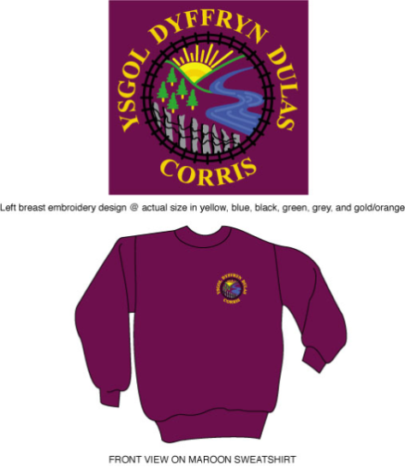

**FFURFLEN GAIS ABSENOLDEB DISGYBL YN YSTOD Y TYMOR**

**APPLICATION FORM FOR PUPIL ABSENCE DURING TERM TIME**

**Mae gan benaethiaid ddisgresiwn i gymeradwyo hyd at ddeg diwrnod yn unig o wyliau yn ystod y tymor ym mhob blwyddyn ysgol.**

**Head teachers have discretion to approve up to ten days holiday in term time per school year.**

Hoffwn ofyn am ganiatâd i fy mhlentyn / fy mhlant fod yn absennol o’r ysgol am y rheswm canlynol:____________________________________________

________________________________________________________________

I would like to request authorisation for my child /children to be absent from school for the following reason:______________________________________

________________________________________________________________

**Enw(au) / Name(s)………………………………………**

**………………………………………**

**………………………………..……**

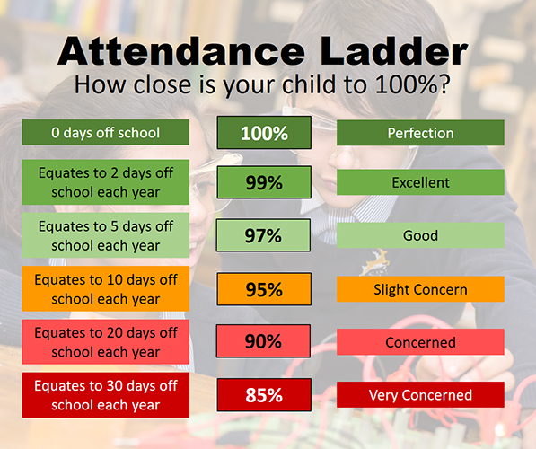

**Dyddiadau absenoldeb/Dates of absence:**

**O/From………………………………**

**I/To ……………………………………**

**frArwyddwyd/Signed…………………………………………………………**

**At ddefnydd swyddfa:**

Wedi ei gymeradwyo / Heb ei gymeradwyo

Arwyddwyd ___________________________________ Dyddiad ___________