

**Ffederasiwn**

**Ysgol Dyffryn Dulas Corris**

**ac Ysgol Pennal**

**Llawlyfr**

**2019 - 2020**

**Prospectus**

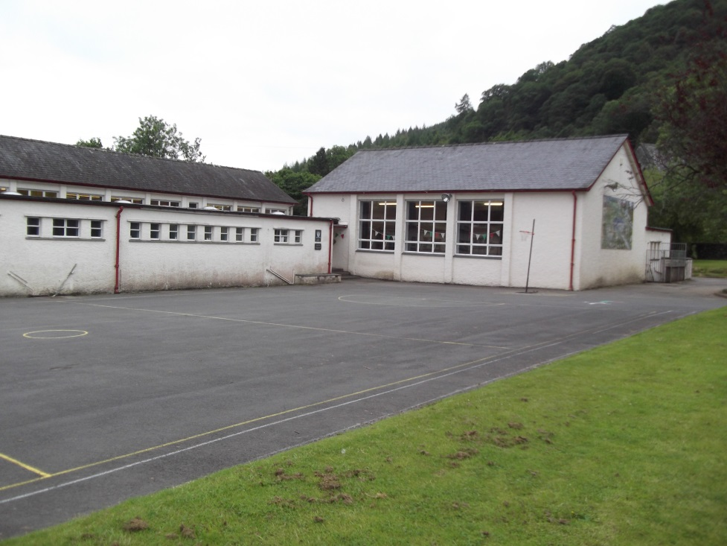

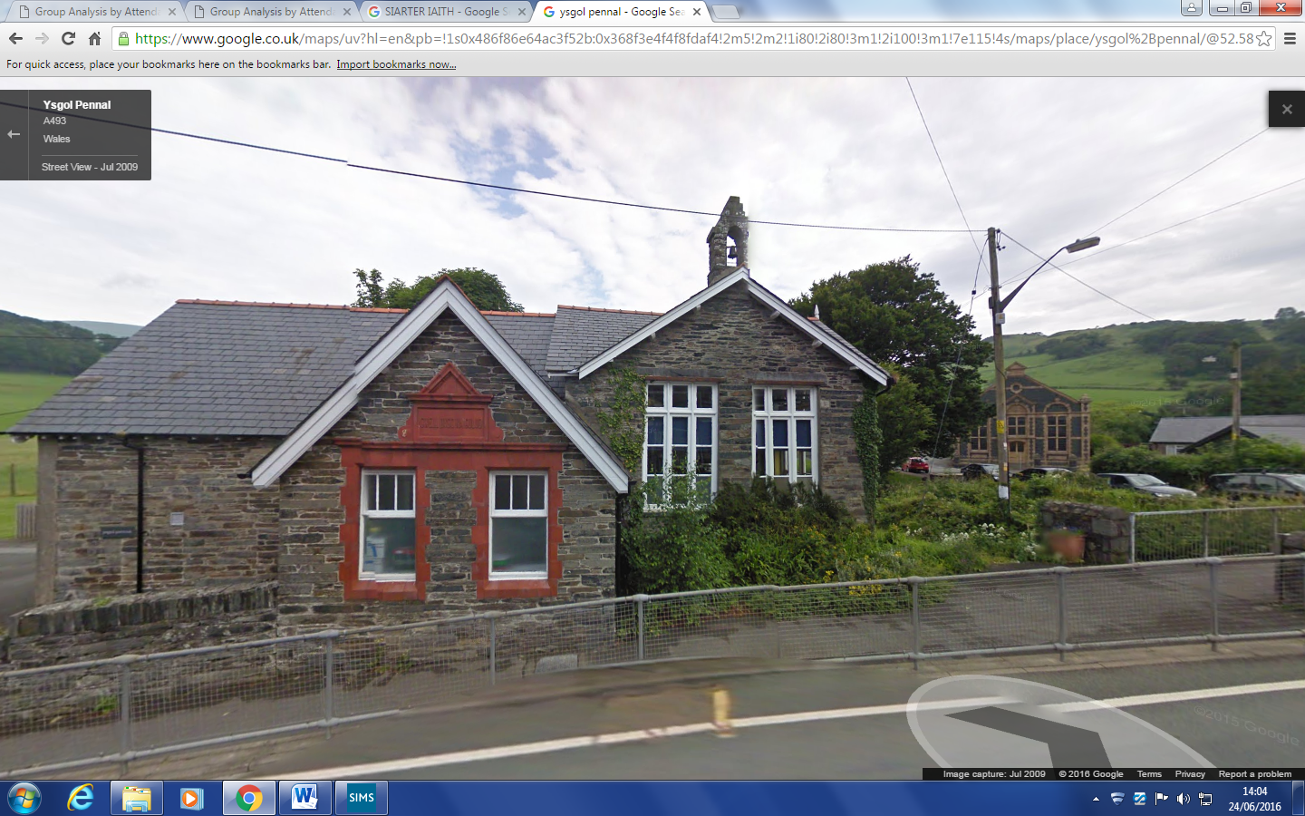



***‘Plant Llawen a Llwyddiannus’***

Annwyl Riant /Warcheidwad,

Croeso i Ffederasiwn Ysgol Dyffryn Dulas Corris ac Ysgol Pennal.

Wrth gyflwyno’r llawlyfr ‘Gwybodaeth i Rieni’ fe garwn estyn croeso cynnes i’ch plentyn i’r Ffederasiwn. Pwysleisiwn mai partneriaeth yw addysg rhyngom ni yma a chwithau yn y cartref. Mewn cyd-weithrediad, mawr hyderwn y bydd cyfnod eich plentyn gyda ni yn un hapus ac y bydd yn datblygu’n addysgol a chymdeithasol mewn amgylchedd cwbl ddiogel. Gobeithiwn y bydd y llawlyfr yma o gymorth i chi adnabod y Ffederasiwn a’r modd y gallwch chi atgyfnerthu ein gwaith gyda’ch plentyn.

Cyflwynir manylion am nifer o faterion dydd i ddydd ac i helpu’ch plentyn ymgartrefu’n fuan. Er hynny nid oes modd cynnwys yr holl wybodaeth am y Ffederasiwn yma, ac fe nodir y gall rhai manylion newid rhwng amser cyhoeddi’r llawlyfr a dechrau’r flwyddyn ysgol.

Fe’ch gwahoddir i drafod ei gynnwys, neu unrhyw beth nad ydyw wedi ei gynnwys, gyda mi trwy wneud trefniadau i ymweld â’r ysgol.

Yn gywir iawn

**Mrs Helen Louise Newell Jones**

**Pennaeth**

Dear Parent /Guardian,

Welcome to *Ffederasiwn Ysgol Dyffryn Dulas Corris ac Ysgol Pennal.* It gives me great pleasure to offer you this handbook, *‘Information for Parents’* and to welcome your child to the Federation. I emphasise from the outset that education is a partnership between the school and the home. With your cooperation we hope that your child’s time here will be happy and that he/she will develop educationally and socially in a safe environment.

This handbook contains information vital to the day to day management of the school which will assist your child to settle down quickly. However the handbook is not definitive and whilst the particulars were correct at the time of publication, there could be changes before the beginning of the school year.

You may make arrangements to visit the Federation to discuss the contents of this handbook or any other matter. I am happy to offer my assistance.

Yours sincerely

**Mrs Helen Louise Newell Jones**

**Head teacher**

**Ffederasiwn Ysgol Dyffryn Dulas Corris ac Ysgol Pennal**

Ysgol Dyffryn Dulas Ysgol Pennal

**Corris Pennal**

**Machynlleth Machynlleth**

**Powys SY20 9TQ**

**SY20 9JT** 🕾01654 761622 🕾01654 791225

🖱[helenlouisenewell-jones@gwynedd.gov.uk](mailto:helenlouisenewell-jones@gwynedd.gov.uk)

CADEIRYDD / CHAIR : Mr Alwyn Rees

PENNAETH */ HEADTEACHER:*  Mrs Helen Louise Newell Jones

CLERC Y LLYWODRAETHWYR: Mrs Eirian Jones

*CLERK TO THE GOVERNORS*:

**Y Corff Llywodraethu / Governing Body**

**Aelodau / Members Swydd - Yn cynrychioli**

**Role – Representing**

Mr Alwyn Rees Cadeirydd / Rhieni – Chair / parents (Pennal)

Mr Dennis Jones Is-Gadeirydd / Cyngor Cymuned

Vice-chair / Community Council

Mr Rhys Parry Cyngor Cymuned / Community Council (Pennal)

Mr John Pugh Roberts A.A.Ll / Local Education Authority

Mr Dewi Owen A.A.LL / Local Education Authority

Mrs Ann Roberts Cymunedol / Community (Pennal)

Anghenion Arbennig / Special Needs

Amddiffyn Plant / Child Protection

Mrs Sharon Wells Cymunedol / Community (Corris)

Mr Nick Young Rhieni / Parents (Corris)

Mrs S Furlong-Davies Rhieni / Parents (Corris)

Mrs Corina Owen Davies Rhieni / Parents (Pennal)

Mrs Kayla Lockett Staff (Pennal)

Mrs Eirlys Wyn Jones Staff (Corris)

Mrs Janet Owen-Durham Staff ategol / Auxiliary staff (Pennal)

Staff ategol / Auxiliary staff (Corris)

Mrs Helen Jones Pennaeth / Headteacher

**STAFF Y FFEDERASIWN / FEDERATION STAFF**

**Pennaeth / Head teacher** – Helen Louise Newell Jones

**Ysgol Dyffryn Dulas Corris Ysgol Pennal**

**Pennaeth Mewn Gofal** Mrs Eirlys Wyn Jones Mrs Kayla Lockett

**Blwyddyn (3), 4, 5, 6** Mrs Eirlys Wyn Jones Miss Miriam Parry

Year (3), 4, 5, 6 Mrs Helen Jones Mrs Helen Jones

**Meithrin, Derbyn, 1, 2, (3)** Mrs Nia Rowlands Mrs Kayla Lockett

Nursery, reception, 1, 2, (3) Mrs Helen Jones

**Cymhorthydd Meithrin** Mrs Leanne Hughes Mrs Janet Owen-Durham

**Nursery Assistant** Mrs Elen Court (0.5)

**Cymhorthydd AAA** Mrs Elen CourtMrs Janet Owen-Durham

**SEN Assistant** Miss Elin Humphreys

Mrs Sharon Wells

**Cogyddes** Mrs Val Jones Mrs Olwen Hulme

**Clerc cinio / Dinner Clerk** Mrs Sharon Wells Mrs Olwen Hulme

**Ysgrifenyddes / Secretary** Mrs Sharon Wells Mrs Janet Owen-Durham

**Gofalwr / Caretaker** Mrs Sharon Sandells Mrs Carla Humphreys

**DISGRIFIAD O'R FFEDERASIWN:** Ffederasiwn Gynradd Cyfrwng Cymraeg Sirol yw'r Ffederasiwn hon.

Mae'n Ffederasiwn ddyddiol, gyd-addysgol.

***DESCRIPTION OF THE SCHOOL:*** *This school is a Welsh Mediun County*

*Primary School*

*It is a day, co-educational school.*

ORIAU DYSGU/*TEACHING HOURS*

**Meithrin / Nursery** 10 yr wythnos / a week

**Y Cyfnod Sylfaen / The Foundation Phase** 24 yr wythnos / a week

**Cyfnod Allweddol 2 / Key Stage 2** 24 yr wythnos / a week

Sesiwn y bore: 9.00 a.m. - 12.00 Sesiwn y pnawn: 1.00 - 3.30 p.m.

*Morning session: 9.00 a.m. - 12.00 Afternoon Session: 1.00 - 3.30 p.m.*

**HAWL RHIENI I ALW AM GYFARFOD**

Roedd yn arfer bod yn ofynnol i gyrff llywodraethu ysgolion gynnal cyfarfod blynyddol gyda rhieni. Cafodd y gofyniad hwnnw ei ddileu gan Ddeddf Safonau a Threfniadaeth Ysgolion (Cymru) 2013 (y Ddeddf). Yn lle hynny, cyflwynwyd trefniadau newydd fel y bo modd i rieni ofyn am hyd at 3 chyfarfod gyda chorff llywodraethu mewn unrhyw flwyddyn ysgol, i drafod materion sy’n peri pryder iddyn nhw. Os yw rhieni am arfer eu hawliau dan y Ddeddf i gynnal cyfarfod, bydd angen bodloni 4 gofyniad:

**1. Bydd angen i rieni gyflwyno deiseb o blaid cynnal cyfarfod.**

Bydd angen i rieni o leiaf 10% o ddisgyblion cofrestredig yr ysgol lofnodi’r ddeiseb. Yn achos deiseb ar bapur, rhaid rhoi llofnod ysgrifenedig, yn ogystal ag enw a dosbarth pob plentyn sy’n ddisgybl cofrestredig yn yr ysgol. Os yw’r ddeiseb yn un electronig, bydd angen i riant ‘lofnodi’ drwy deipio ei enw a bydd rhaid rhoi enw a dosbarth pob plentyn sy’n ddisgybl cofrestredig yn yr ysgol a chyfeiriad e-bost pob rhiant sy’n ‘llofnodi’r’ ddeiseb electronig.

Roedd 22 (Pennal) a 64 (Dyffryn Dulas) o blant wedi’u cofrestru gyda’r Ffederasiwn ar ddechrau’r flwyddyn academaidd hon. Gallwch gysylltu â phennaeth yr ysgol i gael gwybod yn union faint sydd ar y gofrestr ar unrhyw adeg yn ystod y flwyddyn.

**2. Rhaid galw’r cyfarfod i drafod materion sy’n effeithio ar yr ysgol.**

Ni ellir galw cyfarfod i drafod materion fel cynnydd disgyblion unigol, neu er mwyn gwneud cwyn yn erbyn aelod o staff yr ysgol neu aelod o’r corff llywodraethu. Dylai’r ddeiseb gynnwys manylion cryno am y mater(ion) i’w trafod, a’r rhesymau dros alw’r cyfarfod. Dylid dangos yr wybodaeth honno’n glir ar frig y ddeiseb, a dylai’r rhieni lofnodi oddi tani.

**3. Ceir cynnal uchafswm o 3 chyfarfod yn ystod y flwyddyn ysgol**

Mae’r gyfraith yn caniatáu i rieni arfer eu hawliau i ofyn am hyd at 3 chyfarfod gyda chorff llywodraethu ysgol yn ystod y flwyddyn ysgol.

**4. Rhaid bod o leiaf 25 o ddiwrnodau ysgol ar ôl yn y flwyddyn ysgol**

Mae’n amod dan y gyfraith fod o leiaf 25 o ddiwrnodau ysgol ar ôl yn y flwyddyn ysgol pan fo’r ddeiseb yn dod i law, a hynny fel y bo modd cynnal y cyfarfod. Ystyr “diwrnod ysgol” yw diwrnod pan fo’r ysgol yn agored i ddisgyblion: nid yw’n cynnwys penwythnosau, gwyliau cyhoeddus, gwyliau ysgol na diwrnodau Hyfforddiant mewn Swydd (HMS). Dylid defnyddio'r cyfeiriad neu'r ebost uchod ar gyfer cyflwyno deiseb yn gofyn am gyfarfod gyda chorff llywodraethu’r ysgol.

Mae rhagor o wybodaeth i’w gweld ar wefan Llywodraeth Cymru ynghylch sut gall rhieni fynd ati i ofyn am gyfarfod gyda chorff llywodraethu:

<http://wales.gov.uk/topics/educationandskills/publications/guidance/parents-meetingsstatutory-guidance/?lang=cy>

**PARENTS RIGHTS TO CALL A MEETING**

The Schools Standards and Organisation (Wales) Act 2013 (The Act) removed the requirement for school governing bodies to hold an annual meeting with parents. Instead, new arrangements were introduced to enable parents to request up to 3 meetings in any school year with a governing body, on matters which are of concern to them. If parents wish to use their rights under the Act to hold a meeting, 4 conditions will need to be satisfied:

**1. Parents will need to raise a petition in support of holding a meeting.**

The parents of at least 10% of the school’s registered pupils will need to sign the petition. If it is a paper petition, then a written signature must be given as well as the name and class of each child who is a registered pupil at the school. If the petition is in electronic format, the ‘signature’ required is the typed name of the parent plus the name and class of each child who is a registered pupil at the school and the email address of each parent who ‘signs’ the electronic petition.

There were 22 (Pennal) and 64 (Dyffryn Dulas) children registered as pupils with this school at the beginning of this academic year. Exact roll numbers at any time during the year may be obtained from the headteacher.

**2. The meeting must be called to discuss matters which affect the school**

The meeting cannot be called to discuss such matters as the progress of individual pupils, or to make a compliant against a member of the school’s staff or governing body.The petition should contain brief details of the matter(s) to be discussed, and the reasons for calling the meeting. This information should be clearly displayed at the top of the petition, with parents’ signatures appearing below.

**3. A maximum of 3 meetings can be held during the school year**

The law allows parents to use their rights to request up to 3 meetings with a school governing body during the school year.

**4. There must be at least 25 school days left in the school year**

The law makes it a condition that at least 25 school days are left in the school year when the petition is received so that the meeting can be held. A “school day” means a day when the school is open to pupils: it does not include weekends, public holidays, school holidays or INSET days. The above address should be used to request a meeting with this school’s governing body.

Further advice on how parents may to go about requesting a meeting with a governing body is available on the Welsh Government’s website at:

<http://wales.gov.uk/topics/educationandskills/publications/guidance/parents-meetings-statutory-guidance/?lang=en>

**Diogelwch Disgyblion, Staff ac Eiddo’r Ffederasiwn**

Rhaid i bob ymwelydd ddod at y brif fynedfa a mewngofnodi cyn cael mynediad i weddill yr ysgol.

Rydym yn dilyn Polisi Iechyd a Diogelwch Corfforaethol y sir, ac mae copi ohono ar gael yn yr ysgol.

Sylwer - **nid oes yswiriant gennym ar gyfer colledion sy’n digwydd yn yr ysgol.**

**Safety of Pupils, Staff and School Property**

All visitors must come to the main entrance and sign in before gaining access to the rest of the school.

We follow the corporate Health and Safety Policy and a copy of it is in the school.

**Please note that we have no insurance for losses that occur within the school.**

**Amcanion Y Ffederasiwn**

Creu sefyllfaoedd ac adnoddau a fydd yn galluogi pob plentyn i dyfu’n bersonoliaeth lawn, i ddatblygu ac ymarfer ei holl ddoniau. Bydd y sefyllfaoedd a’r adnoddau hyn yn darparu ar gyfer pob plentyn yn ôl oedran, gallu a diddordeb, ac yn eu cymhwyso i fod yn aelodau cyfrifol o gymdeithas ddwyieithog, yn aelodau a fydd yn gallu cyfrannu a derbyn oddi wrthi gan fyw mewn hedd a brawdgarwch gyda’i gyd-ddyn.

**Amcanion Cyffredinol y Ffederasiwn:**

• I bob plentyn deimlo’n hapus a diogel mewn awyrgylch gartrefol.

• I bob plentyn ddatblygu hyd eithaf ei allu

• I gyflwyno addysg sy’n ystyrlon ac yn berthnasol i brofiad disgybl yn y gymuned

• I hybu a datblygu dwyieithrwydd.

• I gynnig cyfle cyfartal i bob disgybl.

• I hybu cysylltiad a chydweithrediad rhieni.

• I feithrin parch at eiddo ac at bersonau eraill.

• I ysgogi cysylltiad â’r gymuned.

• I bwysleisio ymddygiad, cwrteisi ac ymddangosiad cadarnhaol.

• I feithrin athrawon ymroddgar a brwdfrydig.

**THE** **FEDERATION’S AIMS**

To create opportunities and to supply resources which will allow each child to develop an integral personality and to develop and utilise his or her talents. These situations and resources will provide for each child, according to age, ability and interest, and will help them become responsible and participating members of a bilingual society – members who can contribute and gain from their society, co-existing in a spirit of peace and friendship with his/her co-citizens.

**General aims of the Federation:**

• Every child to feel safe and content in a homely atmosphere.

• Every child to be given the opportunity to develop to his or her full potential

• To provide a meaningful education, relevant to the child’s experience in the community.

• To promote and develop bilingualism.

• To offer equal opportunity.

• To promote contact and co-operation with parents.

• To encourage a respect for property and for other people.

• To stimulate contact with the community.

• To place an emphasis on good behaviour, courtesy and appearance.

• To foster dedicated and enthusiastic teaching staff.

**Y CWRICWLWM**

Ar hyn o bryd mae’r Ffederasiwn yn arfarnu’r cwricwlwm er mwyn penderfynu beth sydd angen ei wneud i gyflawni’r **Cwricwlwm Newydd i Gymru.** Mae’r Ffederasiwn eisoes wedi dechrau ymateb i’r argymhellion yn y ddogfen ddrafft ac rydym hefyd yn ymgynghori gyda rhieni i ganfod sut yr hoffen nhw i’r cwricwlwm y mae’r Ffederasiwn yn ei gynnig, newid.

Am fwy o wybodaeth ewch i <https://hwb.gov.wales/cwricwlwm-drafft-i-gymru-2022/>

Yn y cyfamser, ac yn unol â gofynion Cwricwlm 2008, mae'r Awdurdod Addysg wedi llunio, ac yn bwriadu adolygu'n rheolaidd, ddatganiad ysgrifenedig o'i bolisi mewn perthynas â'r cwricwlwm seciwlar. Dehonglir gofynion y Cwricwlwm yng nghyd-destun athroniaeth a pholisiau yr Awdurdod.

Dyfynnir isod ragair ac amcanion cyffredinol y datganiad fel y gwelir hwynt yn nogfen yr Awdurdod Addysg:

**Rhagair**

Pwrpas cyfundrefn addysg yw creu sefyllfaoedd a chyflenwi adnoddau fydd yn galluogi pob plentyn i dyfu yn bersonoliaeth lawn, i ddatblygu ac ymarfer ei holl ddoniau, fydd yn darparu ar ei gyfer yn ôl oedran, gallu a diddordeb, ac yn ei gymhwyso i fod yn aelod cyfrifol o gymdeithas ddwyieithog, yn aelod fydd yn gallu cyfrannu iddi a derbyn oddi wrthi, a byw mewn heddwch a brawdgarwch gyda'i gyd-ddyn.

Y mae i'r datganiad cyffredinol hwn dair agwedd gyd-berthnasol.

(a) Galluogi pob plentyn i ddatblygu i'w lawn botensial.

(b) Sicrhau bod pob plentyn yn cael ei gyflwyno i'r etifeddiaeth Gymreig.

(c) Rhoi cyfle i bob plentyn ddatblygu fel aelod llawn o gymdeithas sy'n prysur newid.

**Amcanion cyffredinol**

1. Cyflwyno’r Strategaethau Llythrennedd a Rhifedd yng nghyd-destun symbylu chwilfrydedd, dychymyg a diddordeb y plentyn.

2 Cynyddu gwybodaeth y plentyn a datblygu ei allu i resymu er mwyn ei gynorthwyo i addasu i fyd sy'n cyflym newid ac yn mynd yn fwy soffistigedig yn ei brosesau a'i dechnegau, yn arbennig mewn perthynas â thechnoleg hysbysiaeth.

3. Creu ym mhob plentyn yr awydd i geisio am fwy o wybodaeth a phrofiadau yn ystod ei fywyd, a datblygu ei feddwl a'i synnwyr moesol ac ysbrydol.

4. Cynorthwyo'r plentyn i fedru byw a gweithio gydag eraill a datblygu agweddau fydd yn ei alluogi i fod yn aelod cyfrifol o gymdeithas.

5. Datblygu yn y plentyn sensitifrwydd, gwerthfawrogiad esthetig a sgiliau hamdden.

6. Rhoi sylw arbennig i bob plentyn sydd ag anghenion arbennig, e.e. rhai eithriadol o alluog a rhai sydd dan anfanteision amrywiol.

7. Cyflwyno syniadau a chysyniadau a hynny trwy ddulliau bywiog a deinamig sy'n hawlio ymateb y disgybl.

**Mynediad a Chyfleoedd Cyfartal**

Bydd staff y Ffederasiwn yn gwneud eu gorau i sicrhau y caiff pob disgybl gyfle cyfartal i gyrraedd ei botensial. Bydd amgylchedd gweithgar yr ystafell ddosbarth, ac amgylchedd yr ysgol yn gyffredinol, yn adlewyrchu pob disgybl a’i hawl i gael mynediad llawn i raglen astudio pob pwnc.

Manteisir ar bob cyfle i ddarparu’n wahaniaethol er mwyn datblygu ac ymestyn disgyblion i’w llawn potensial.

**Plant Sy’n Derbyn Gofal**

**Mrs Helen Jones** sy’n benodol gyfrifol am hyrwyddo cyflawniad plant sy’n derbyn gofal.

**THE CURRICULUM**

The Federation is currently evaluating its curriculum in order to determine what needs to be done to successfully realize the **New Curriculum for Wales.** The Federation has already started to respond to the recommendations in the draft document and we are also consulting with parents to find out how they would like the curriculum offered by the Federation, to change.

For more information visit <https://hwb.gov.wales/cwricwlwm-drafft-i-gymru-2022/>

In the meantime, and in accordance with the requirements of the Education Act 1986, the Education Authority has formed, and intends to review regularly, a written statement of policy regarding the secular curriculum. The requirements of the National Curriculum will be interpreted in the light of the Authority's present policies and philosophy.

Quoted below is the introduction, and general aims of the statement as seen in the Education Authority's document:

**Introduction**

The aim of an education system is to create situations and provide resources that will enable each child to develop a full personality, to develop and exercise all his or her abilities, to provide for the pupil in accordance with his/her age, ability and aptitude, so that he/she is able to become a responsible member of a bilingual society, able to contribute to that society and benefit from it, and to live in peace and fraternity with fellow men.

There are three inter-related aspects to the general statements, i.e. the need:

(a) To enable each child to develop his/her full potential.

(b) To ensure that each child is introduced to his/her Welsh heritage.

(c) To give an opportunity for each child to develop as a full member of a rapidly changing society.

**General objectives**

1. To present the Language and Literacy Framework in the context of inspiring the child's enthusiasm, imagination and interest.

2. To increase the child's knowledge and to develop his powers of reasoning in order to assist him to adapt to a rapidly changing world which has more sophisticated processes and techniques, in particular in relation to information technology.

3. To create in each child the desire to seek further knowledge and experience during his life and to develop his powers of mind, his moral and spiritual awareness.

4. To assist the child to live and work with others and to develop attitudes which will enable him/her to become a responsible member of the community.

5. To develop sensitivity, aesthetic appreciation and leisure skills in the child.

6. To provide particular attention for each child with special needs, e.g. for the exceptionally able and for those with various disadvantages.

7. To present ideas and concepts by employing lively and dynamic methods that will motivate pupil response.

**Access and Equal Opportunities**

The Federation’s staff will strive to ensure that each child is given an equal opportunity to achieve his/her full potential. The formal environment of the classroom and of the Federation in general, will reflect the equality of each pupil and his/her entitlement to full access to all programmes of study.

Advantage is taken of every opportunity to offer differentiated provision in order to develop and extend pupils to their full potential.

**Looked After Children**

**Mrs Helen Jones** is responsible for fostering the achievement of looked after children.

**CYTUNDEB RHWNG CARTREF AC YSGOL**

Ers Medi 1999 mae gofyn i bob ysgol fod a chytundeb rhwng cartref ac ysgol.

**O safbwynt yr ysgol:**

* Bydd y Ffederasiwn yn sicrhau y darperir rhaglen addysgu eang a chytbwys, sy’n cwrdd â gofynion Cwricwlwm 2008, y Fframwaith Llythrennedd a Rhifedd a Chymhwysedd Digidol – hefyd Cwricwlwm i Gymru (draft) 2022.
* Gwneir pob ymdrech i sicrhau bod pob disgybl yn gweithio hyd eithaf ei (g)allu.
* Gwneir pob ymdrech i baratoi amgylchedd ddiogel a gofalgar i bob disgybl.
* Bydd y Ffederasiwn yn darparu gwaith cartref yn dibynnu ar oedran y disgyblion – darllen yn bennaf.
* Bydd yr ysgol yn:

⇒ darparu gwybodaeth rheolaidd i rieni

⇒ darparu gwybodaeth am ddatblygiad plant

⇒ cysylltu ar fyrder ynghylch unrhyw bryderon

* Bydd yr ysgol yn rhoi sylw teilwng a phrydlon i unrhyw bryder

**O safbwynt rhieni/gwarcheidwaid:**

Disgwylir i rieni/gwarcheidwaid:

* roi pob cymorth a chefnogaeth i ddisgyblion gyda’u haddysg
* gefnogi unrhyw weithgaredd a osodir gan yr ysgol gan gynnwys gwaith cartref/darllen rheolaidd/dysgu tablau a.y.y.b
* fynychu nosweithiau rhieni a chyfarfodydd sydd wedi’u trefnu ar gyfer trafod datblygiad disgyblion
* sicrhau prydlondeb
* cydymffurfio â pholisi ymddygiad
* annog disgyblion i feithrin hunan barch a pharch at eraill
* **gysylltu â’r ysgol ar unwaith mewn unrhyw achos o absenoldeb.**

***********************************************

***HOME SCHOOL AGREEMENT***

*Since September 1999 every school has a home-school agreement*

***School Agreement:***

* *The Federation will ensure a broad and balanced teaching programme, which will fully meet the requirements of the current Curriculum, the National Numeracy and Literacy Framework and the Digital Competancy Framework and aspects of the new draft Curriculum for Wales*
* *The Federation endeavours to ensure that every child works to his/her utmost ability*
* *The Federation endeavours to guarantee a secure and caring environment for every pupil*
* *The Federation will set regular homework depending on the child’s age – mainly reading practice*
* *The Federation will :*

*⇒ communicate regular information*

*⇒ communicate information about a child’s development*

*⇒ inform parents of any cause for concern*

* *The Federation will take appropriate and swift actions regarding any concerns you may voice*

***Parents’/Carers Agreement:***

*Parents / Carers are expected to:*

* *support and encourage children*
* *support activities organised by the school, including home work / to read regulary with the child / help to learn the time tables etc*
* *attend parents’ evenings and other meetings*
* *ensure punctuality*
* *ensure that children follow the School Behaviour Policy*
* *encourage children to be considerate*
* ***Inform the school at once if the child is absent for any reason.***

**PATRWM GWAITH**

Ceisir sicrhau fod yr addysg a ddarperir yn hybu pob disgybl i fod yn ddysgwyr chwilfrydig, brwdfrydig a blaengar sydd â’r gallu i ymdopi â sialensau y byd o’u cwmpas fel dysgwyr gydol oes effeithiol. I ymateb â'r gofynion hyn bydd trefniadaeth y dosbarth yn hyblyg; weithiau darperir gwaith ar sail oedran plant, dro arall bydd plant o ystod oedran sy'n rhychwantu mwy nag un blwyddyn ysgol yn cyd-weithio ar yr un dasg; hefyd def nyddir yr awyr agored fel estyniad o’r ystafell ddosbarth. Rhan amlaf, dysgir y plant fel uned dosbarth fydd o dan ofal un athrawes/athro sefydlog.

Yn ôl awgrym Cyngor Cwricwlwm Cymru, cynllunnir y cwricwlwm i gynnwys y pynciau craidd a sylfaen, y Fframwaith Llythrennedd, Rhifedd, Cymhwysedd Digidol ac agweddau o’r cwricwlwm newydd i Gymru. Nodir cyfraniad y meysydd hyn mewn dull systematig yng nghofnodion yr athro/athrawes. Er mwyn sicrhau nag eithrir elfennau hanfodol o'r cwricwlwm a’r Fframwaith, cyflwynir y profiadau a'r gweithgareddau i blant yn draws-ddisgyblaethol drwy ddilyn themâu ysgogol.

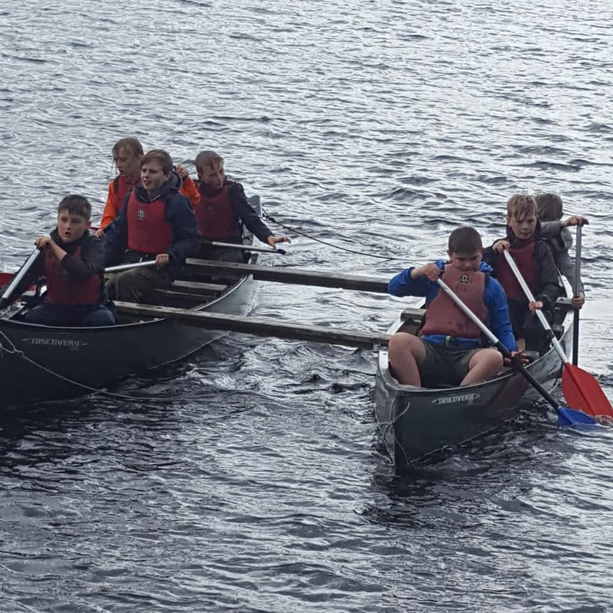

**WORK PATTERN**

Our aim is to ensure that the education provided inspires all pupils to be ambitious, enterprising and creative learners who have the ability to cope with the challenges of the world around them as effective lifelong learners. In order to fulfil these needs class organisation is flexible; work will sometimes be given according to the child's age, at other times children of different age groups spanning more than one school year will work together on one task; children work indoors and outdoors. The children are usually taught as a class unit in the care of one designated teacher.

In accordance with the Curriculum Council for Wales' proposal, the curriculum and Literacy and Numeracy Frameworks, and aspects of the new Curriculum for Wales are planned according to elements, including the core and foundation subjects. The contribution of these subjects are noted systematically in teacher's planning. By giving children tasks and experiences based on specific themes, or on an inter-disciplinary basis, the Federation seeks to ensure that essential elements of the Curriculum and Frameworks are not forgotten.

**GWAITH CARTREF**

Yn achlysurol, bydd gwaith cartref ffurfiol yn cael ei osod. Bydd amlder a swmp y gwaith cartref yn dibynnu ar oed ac anghenion y disgyblion.

Disgwylir i’r holl ddisgyblion ddarllen yn rheolaidd gartref.

Yn ogystal, disgwylir i blant ymarfer eu tablau yn rheolaidd.

**HOMEWORK**

Ocassionally, formal homework is set. The amount and frequency of homework depends on the age of the pupils and their needs.

All pupils are expected to read on a daily basis.

Pupils are expected to practice their times tables regularly.

#### E:\VERBATIM HD\TOSHIBA EXT\LLuniau\Llawlyfr 3.jpgE:\VERBATIM HD\TOSHIBA EXT\LLuniau\llawlyfr 2.jpg

**CYFLE CYFARTAL**

Mae gan y Ffederasiwn Gynllun Cydraddoldeb Strategol sy’n sicrhau cydraddoldeb addysg a chyfle i'r holl ddisgyblion, staff, rhieni a gofalwyr sy'n derbyn gwasanaethau gan yr ysgol, waeth beth yw eu hanabledd, hîl, rhyw, oedran, tueddfryd rhywiol, crefydd neu gred, ailbennu rhywedd, beichiogrwydd a mamolaeth, priodas a phartneriaeth sifil. Rydym yn datblygu diwylliant o gynhwysiad ac amrywiaeth sy'n galluogi pawb sy'n gysylltiedig â'r Ffederasiwn i deimlo'n falch o'i hunaniaeth, a chyfranogi'n llawn ym mywyd yr ysgol. Byddwn yn mynd i'r afael â gwahaniaethu drwy hyrwyddo cydraddoldeb yn gadarnhaol, herio bwlio ac ystrydebau a chreu amgylchedd sy'n hyrwyddo parch at bawb.

#### EQUAL OPPORTUNITIES

The Federation has a Strategic Equality Plan that ensures equality of education and opportunity for all pupils, staff, parents and carers receiving services from the school, irrespective of disability, race, gender, age, sexual orientation, religion or belief, gender reassignment, pregnancy & maternity, marriage and civil partnership. We aim to develop a culture of inclusion and diversity in which all those connected to the Federation feel proud of their identity and able to participate fully in school life.

**CLWB BRECWAST**

Mae’r Clwb Brecwast ar agor o 0815 am gost o 50c y dydd, neu yn ddi-dal o 0830. Yn ystod y cyfnod hwn mae’r plant yn mynd i’r Neuadd / Ffreutur i fwynhau tost, grawnfwyd a sudd. Sicheir goruchwyliaeth o’r plant yn y Neuadd / Ffreutur ac ar y buarth yn ystod y cyfnod hwn, gan barhau hyd at amser cofrestru am 9 o’r gloch.

**CINIO YSGOL**

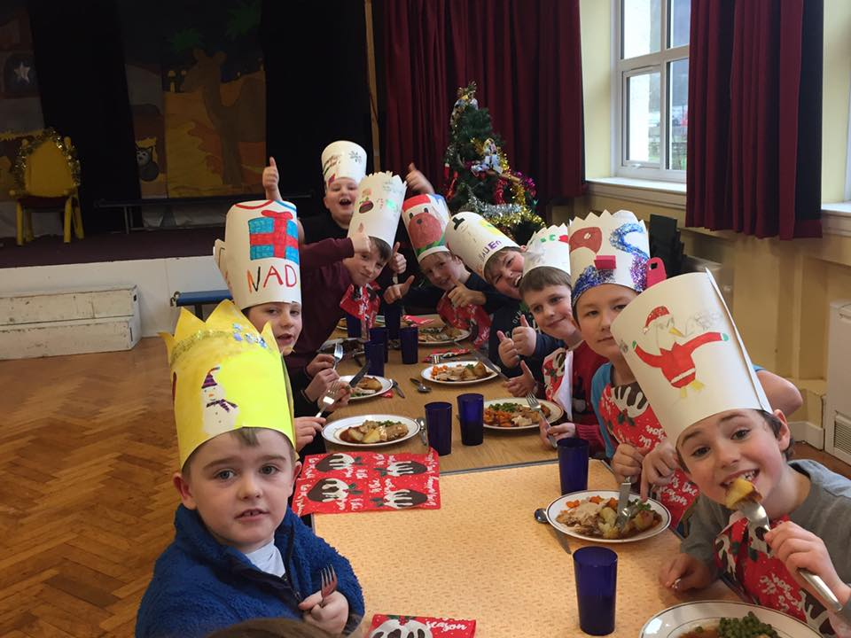Coginir cinio ffres yng nghegin y ddwy ysgol. Arolygir y plant yn ystod yr awr ginio gan gynorthwywyr. Cost cinio ysgol yw £2.50 y dydd. Dylid talu ar lein. I wneuhyn mae’n ofynnol i chwi gwblhau ffurflen a’i ddychwelyd i’r ysgol, er mwyn i’ch cyfrif gael ei greu. Mae’r ysgol yn aelod o’r ‘Rhwydwaith Ysgolion Iach’ ac yn rhoi pwyslais mawr ar fwyta’n iach. Caiff plant ddod â brechdanau.

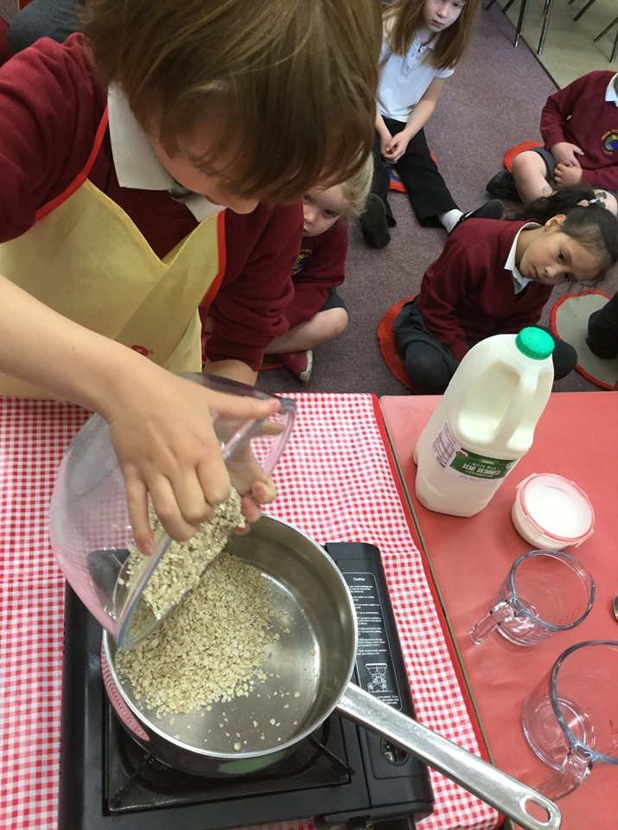

**BREAKFAST CLUB**

The Breakfast Club is open daily from 0815 at a cost of 50p per day, or from 0830 for free. During this period, children go to the hall / canteen to enjoy a slice of toast, bowl of cereal and a glass of juice. Children are supervised in the hall / canten and on the yard during this period, until registration at 9 o’clock.

**SCHOOL LUNCHES**

Lunch is freshly cooked in both school kitchens. The children are supervised at lunchtime. Lunches cost £2.50 / day. Payments should be made online. Please complete the ‘internet payments’ form so that we can create an account for you. The school is a member of the ‘Healthy Schools Network’ and puts great emphasis on healthy eating. Alternatively, children may bring a healthy packed lunch.

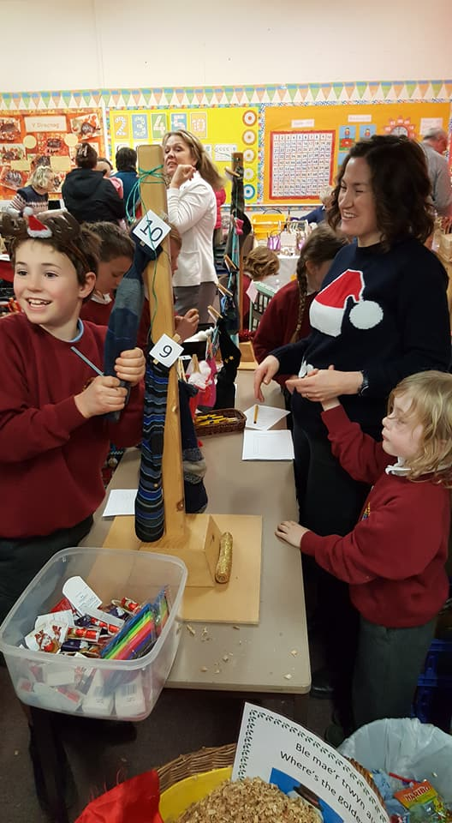**GOFAL BUGEILIOL**

Mae pob plentyn yng ngofal ei athro/athrawes ddosbarth, ond bydd yr holl staff yn ymorol am lês yr holl ddisgyblion ar bob achlysur. Mae'r Ffederasiwn yn annog plant i fod yn hunan-ddisgybledig, yn gyfrifol ac i barchu eraill. Gwyddom y cawn gefnogaeth rhieni yn hyn o beth.

**Disgyblaeth**

Mae polisi Awdurdod Addysg Gwynedd ar ddisgyblaeth mewn ysgolion yn rheoli'r ffordd y disgyblir plant yn y Ffederasiwn. Rydym yn gweithredu egwyddorion cynllun ‘Webster Stratton’ yn y Ffederasiwn ac yn canmol ymddygiad cadarnhaol yn hytrach na cheryddu ymddygiad annerbyniol.

**Cyswllt â'r Cartref**

Ni all y Ffederasiwn lwyddo heb gefnogaeth rhieni. Yr ydym felly yn eich annog i ymddiddori yn addysg eich plant ac i fod yn gefn i'r Ffederasiwn yn ei gwaith ac yn ei gweithgareddau cyhoeddus.

Gall pob riant sy'n dymuno, drafod unrhyw agwedd ar addysg eu plant, drefnu i gyfarfod â’r Pennaeth neu’r athro/athrawes ddosbarth, trwy gysylltu â'r Pennaeth trwy lythyr, dros y ffôn neu ebost.

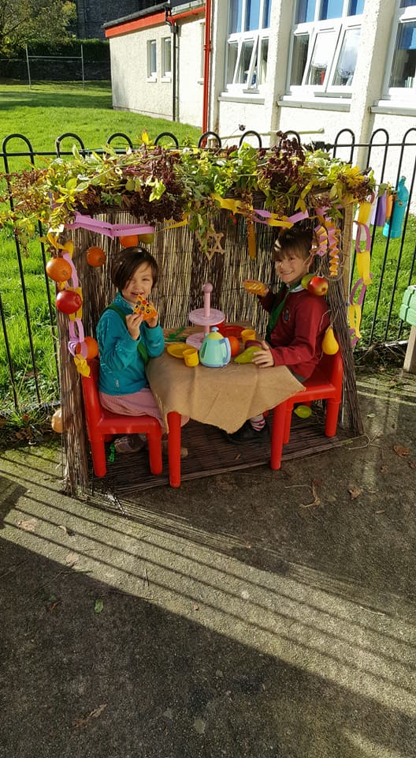

**PASTORAL CARE AND DISCIPLINE**

Every child is placed in the care of the class teacher, but all staff endeavour to take care of all pupils' well-being at all times. The Ffederation advocates self-discipline and respect; we know that we can rely on parental support in this respect.

**Discipline**

Pupils in the Ffederation are disciplined in accordance with the policy laid down by the Gwynedd L.E.A. We implement the principles of the ‘Webster Stratton’ Scheme in the Federation, and promote positive behaviour.

**Home and School Contact**

The Federation cannot succeed without the support of parents. We therefore appeal for you to take an interest in your children's education and to support the Federation in its work and its public activities.

Parents who wishe to discuss any aspect of school life can orchestrate a meeting with the Head teacher/class teacher by contacting the Headteacher via letter, telephone or email.

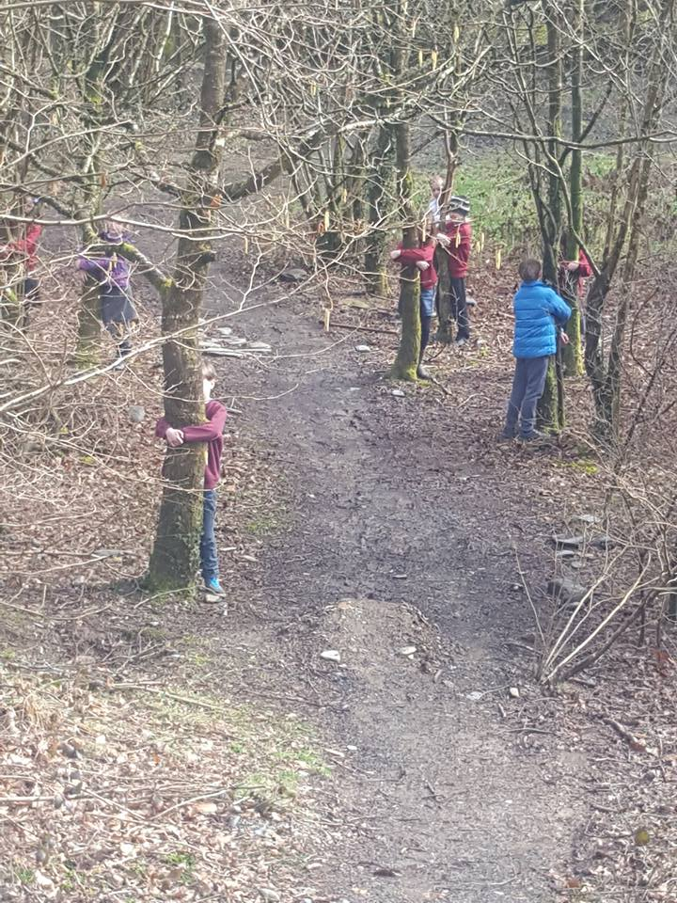

**CREFYDD**

Nid yw'r Ffederasiwn yn dal cysylltiad uniongyrchol a ffurfiol ag unrhyw enwad crefyddol.

Y mae'r addysg grefyddol a gyflwynir yn seiliedig ar faes llafur cydnabyddedig yr Awdurdod. Gellir archwilio copi o'r maes llafur hwn yn yr ysgol.

Fe ellir gwneud trefniadau amgen ar gyfer plant nad yw eu rhieni am iddynt fynychu'r gwasanaethau crefyddol ac astudiaethau cyffelyb.

Fel arfer, bydd gwasanaethau yn Gristnogol a moesol eu naws; ond o bryd i’w gilydd, tynnir sylw at gredoau eraill.

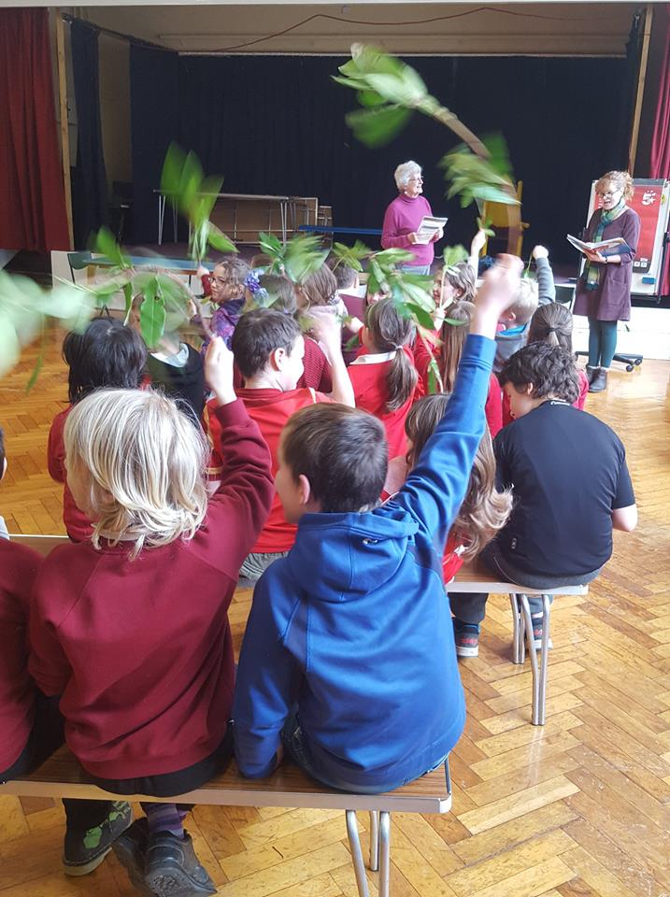

**RELIGIOUS EDUCATION**

The Ffederation has no direct or formal religious affiliation.

The religious education provided is based on Gwynedd’s agreed syllabus, a copy of which may be viewed at the school.

Suitable alternative arrangements can be made for children whose parents object to them receiving religious instruction or attending religious services.

Services are usually Christian and moral based, although other faiths are occasionally discussed.

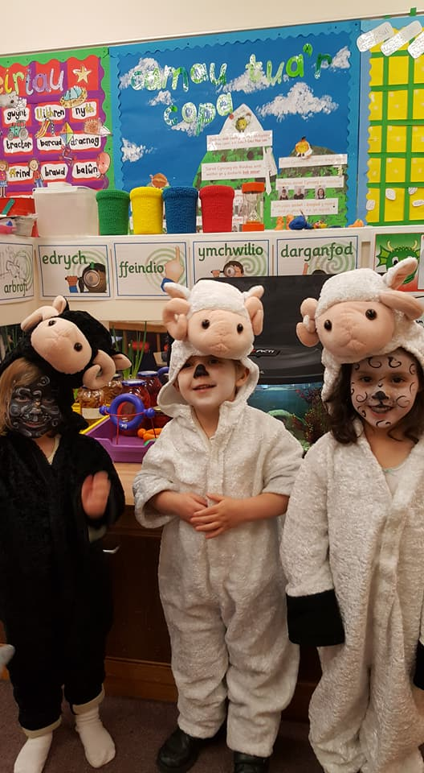

**ADDYSG RHYW**

Mae’r Ffederasiwn yn cymryd rhan yng Nghynllun Ysgolion Iach Gwynedd ac fel rhan o’r gwaith i ddatblygu Addysg Bersonol a Chymdeithasol, yn cyflwyno polisi Addysg Bywyd/Rhyw & Pherthnasedd yn y Cyfnod Sylfaen a Chyfnod Allweddol 2.

Mae gan rieni’r hawl i eithrio eu plant o’r elfennau hynny nad ydynt yn rhan o’r Cwricwlwm Cenedlaethol 2008.

Os oes gan riant/gofalwyr bryder mae croeso iddynt ddod i’r ysgol i drafod gyda’r Pennaeth.

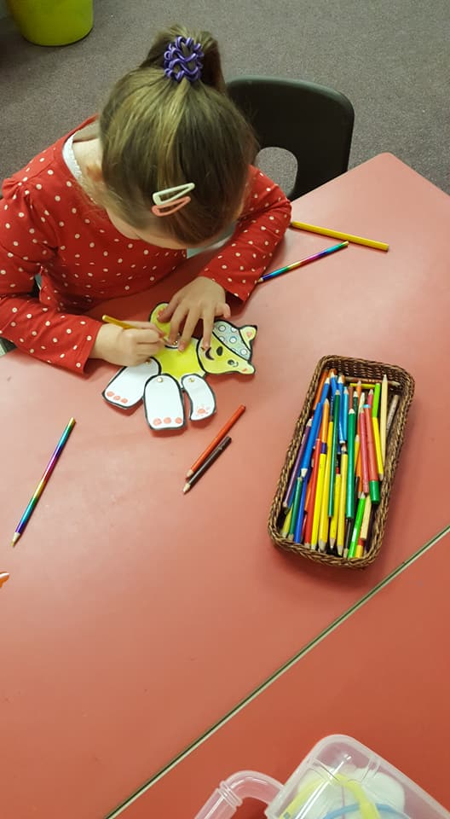

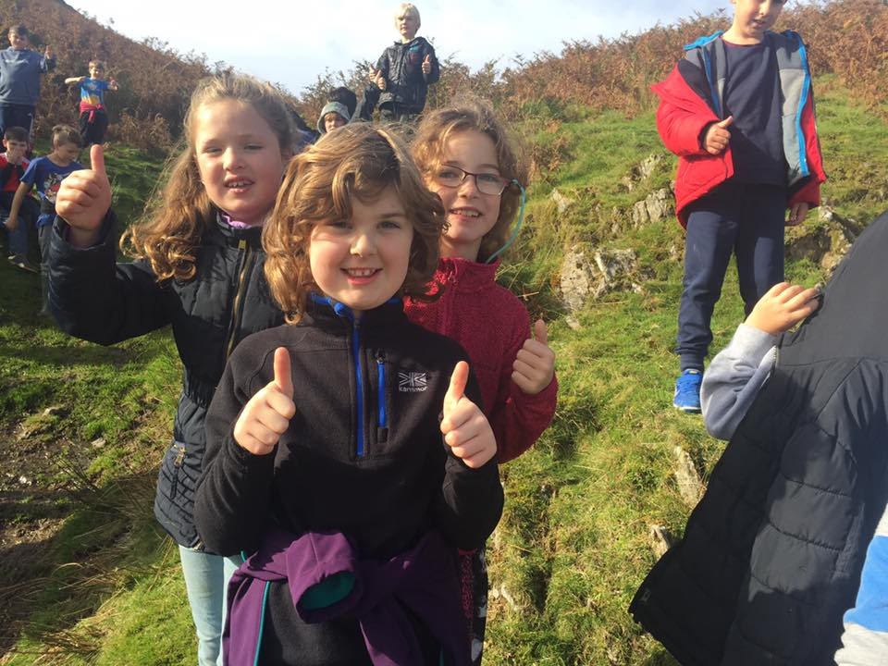

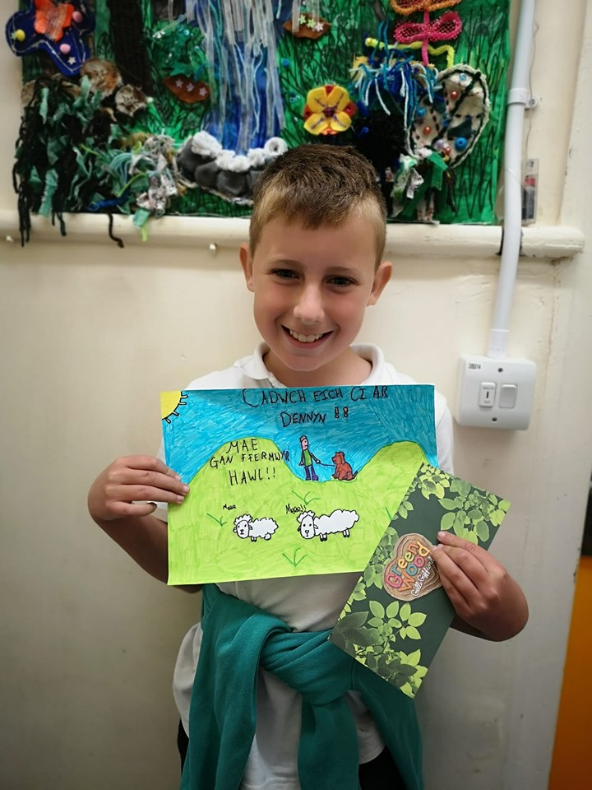

**SEX EDUCATION**

The Federation partakes in Gwynedd’s Healthy School’s Project, and we currently offer provision of ‘Sex and Relationship Education’ at The Foundation Phase and KS2.

Parents are permitted to exclude their children from the aspects of ‘Sex and Relationship Education’ that are not part of the 2008 curriculum.

Parents can discuss worries or uncertainties with the Head teacher.

**GWEITHGAREDDAU YCHWANEGOL**

Gobeithia'r Ffederasiwn sicrhau cyd-weithrediad a chefnogaeth rhieni gyda'r holl weithgareddau ychwanegol a drefnir.

Mae'r Ffederasiwn yn cynnig amrywiaeth o weithgareddau sy'n agored i’r holl ddisgyblion sydd, ym marn y Pennaeth, yn aeddfed ac yn barod i gymryd rhan ynddynt.

* Bydd y Ffederasiwn yn cymeryd rhan yng ngweithgareddau’r Urdd.
* Mae Adran yr Afon yn cwrdd ar nosweithiau Llun.
* Pan fo tywydd yn ffafriol, cynhelir clybiau garddio wythnosol yn y ddwy ysgol
* Fel arfer trefnir trip blynyddol i’r Ffederasiwn gyfan yn ystod tymor yr haf.
* Bydd Cyngerdd Nadolig / gwasanaeth yn cael ei gynnal yn flynyddol.
* Mae plant y Ffederasiwn yn mynychu ac yn cymryd rhan mewn Gwasanaeth Diolchgarwch yn flynyddol.
* Mae’r Ffederasiwn wedi ymrwymo â’r cynllun ‘Ysgol Iach’.
* Gwna’r Ffederasiwn pob ymdrech i gefnogi elusennau
* Rydym yn chwarae rhan lawn ym mywyd y pentrefi.

**Ni all yr ysgol dderbyn cyfrifoldeb am oruchwylio plant ar derfyn sesiynau’r gweithgareddau uchod, a gofynnir i rieni sicrhau eu bod yn gwneud trefniadau i hebrwng y plant adref.**

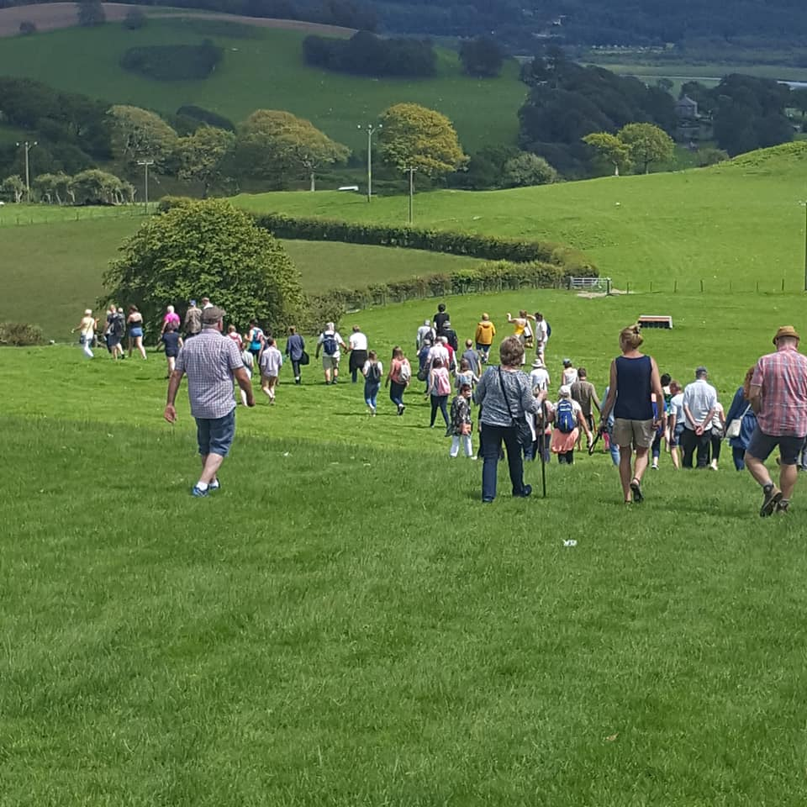

**ADDITIONAL ACTIVITIES**

The Federation aspires to ensure the co-operation and support of parents with all the additional activities organized.

The Federation offers a variety of activities which are open to all pupils who are in the Headteacher's opinion, ready and mature enough to take part in them.

* The Federation takes part in ‘Urdd’ activities.
* Adran yr Afon Urdd meetings are on Mondays.
* Weather permitting, weekly gardening club meetings are held on both sites.
* An annual trip for the Federation is usually organised during the Summer Term.
* An annual Christmas Concert / Christmas Service is held in each village on alternate years
* School pupils take part in a Harvest/Thanksgiving Service annually.
* The school hasenrolled with the ‘Health Promoting’ project.
* The Federtion supports charities
* The school plays a key part in community activities.

**The school cannot accept responsibility for supervising children at the end of the sessions of the above-mentioned activities, and parents/guardians are requested to ensure that they make arrangements to take the children home promptly.**

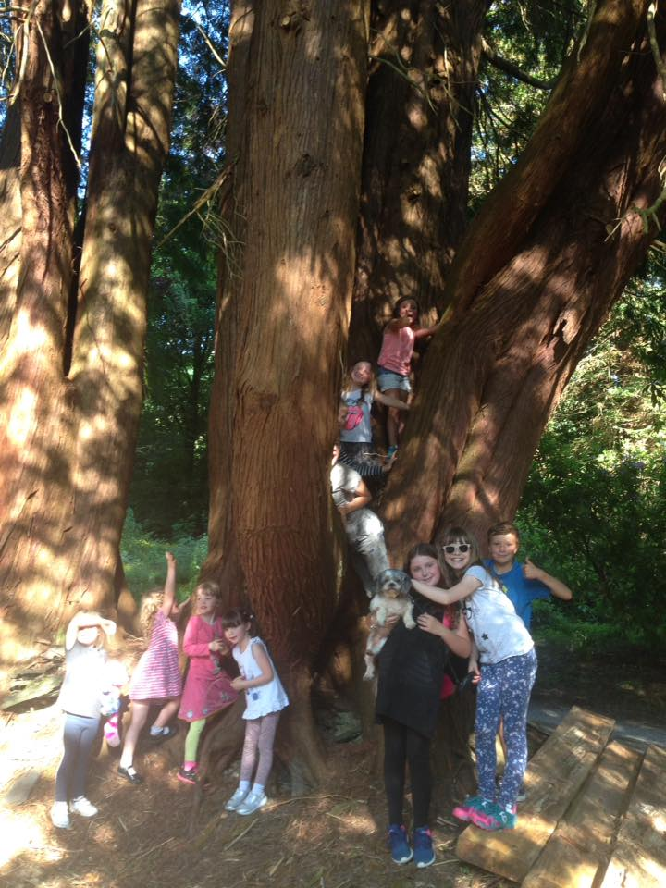

**Mynediad i’r Ffederasiwn**

**Pryd all fy mhlentyn ddechrau addysg meithrin?**

**Meithrinfa Cyn Ysgol Rhan Amser**

Mae’r Awdurdod yn cynnig 10 awr yr wythnos o Addysg Feithrin ddi-dâl i blant yn y tymor yn dilyn eu trydydd pen-blwydd am weddill y flwyddynYsgol. Cynigir y lleoedd gan bartneriaid yn y sectorau gwirfoddol ac annibynnol sydd wedi cofrestru gyda’r Bartneriaeth Blynyddoedd Cynnar a Gofal Plant. Gellir cael rhestr o ddarparwyr trwy gysylltu â Rheolwr Gwasanaeth Y Blynyddoedd Cynnar ar 01286 678824

**Dosbarth MeithrinYsgol Rhan Amser**

Mae’rAwdurdod yn cynnig lle meithrin rhan amser (10 awr yr wythnos) i blant mewn ysgol, yn y mis Medi yn dilyn eu trydydd pen-blwydd, am flwyddyn ysgol lawn. Fel arfer mae gan ysgolion unai sesiwn bore neu sesiwn prynhawn. Mewn ysgolion sydd â sesiwn bore a phrynhawn nid oes hawl cyfreithiol gan rieni i ddewis pa sesiwn gall eu plentyn mynychu. Yn yr ychydig ardaloedd ble nad yw’rAwdurdod yn darparu ar gyfer addysg plant yn y mis Medi yn dilyn eu pen-blwydd yn dair oed mewn dosbarth meithrin mewn ysgol, cynigir darpariaeth trwy gyllido lleoedd a ddarperir gan y grwpiau gwirfoddol h.y. Mudiad Ysgolion Meithrin a Grwpiau chwarae Cyn-Ysgol. Dylid nodi o dan reolau Llywodraeth Cymru nad yw penderfyniad i roi mynediad i blentyn i ddosbarth meithrin yn sicrhau neu wella’r tebygolrwydd o dderbyn lle yn nosbarth derbyn yr ysgol honno.Mae rhaid gwneud cais ar wahân.

**Dosbarth Derbyn Llawn Amser**

Mae’r Awdurdod yn cynnig i blant le llawn amser mewn dosbarth derbyn yn y mis Medi yn dilyn eu pen-blwydd yn bedair oed. Ble cynigir lle yn y flwyddyn derbyn, mae gan rieni'r dewis o ohirio mynediad eu plentyn hyd yn nes ymlaen yn yr un flwyddyn ysgol hyd at y tymor yn dilyn pen-blwydd eu plentyn yn bump oed. Gellir cynnig mynediad ynghynt i ysgol na’r hyn a gynigir o dan y polisi mynediad mewn achosion eithriadol, a gyfeirir am resymau penodol yng nghyd-destun Deddf Plant 1989 trwy’r:

(i) Gwasanaethau Cymdeithasol neu

(ii) Swyddog Meddygol y Sector Perthnasol

Dylid nodi o dan reolau Llywodraeth Cymru nad yw penderfyniad i roi mynediad i blentyn i ddosbarth meithrin yn sicrhau neu wella’r tebygolrwydd o dderbyn lle yn nosbarth derbyn yr ysgol honno. Mae rhaid gwneud cais ar wahân.

**Sut wyf yn ymgeisio am le mewnysgol?**

Yr Adran Addysg yw awdurdod caniatáu mynediad yr ysgolion cymuned a’r rhai sydd o dan reolaeth wirfoddol ac mae’n gyfrifol am wneud penderfyniadau ynghylch mynediad. Nid oes gan benaethiaid yr ysgolion hyn unrhyw ran yn y broses fynediad ac ni fyddant yn trafod y lleoedd sydd ar gael. Rhaid cyflwyno’r holl geisiadau am fynediad i’r Awdurdod yn ysgrifenedig, gan ddefnyddio’r ffurflenni a ddarperir (ar gael yn yr ysgolion neu ar www.gwynedd.gov.uk/mynediadysgolion).

Ni all yr Awdurdod drafod argaeledd lleoedd dros y ffôn. Rhoddir ystyriaeth cyfartal i bob dewis. Cewch eich annog i ddatgan mwy nag un dewis. Gallwch ddefnyddio dalen ar wahân i ddatgan mwy na thri. Os oes lle ar gael mewn mwy nag un ysgol, dim ond eich dewis cyntaf a gynigir i chi. Oni all yr Awdurdod gynnig unrhyw un o’ch dewisiadau i chi, caiff unrhyw ddewis newydd a dderbynnir ei drin fel cais hwyr. Efallai na fydd yr Awdurdod yn gallu cynnig lleoedd i rai sy’n anfon ceisiadau yn hwyr os yw’r ysgolion hynny eisoes yn llawn.

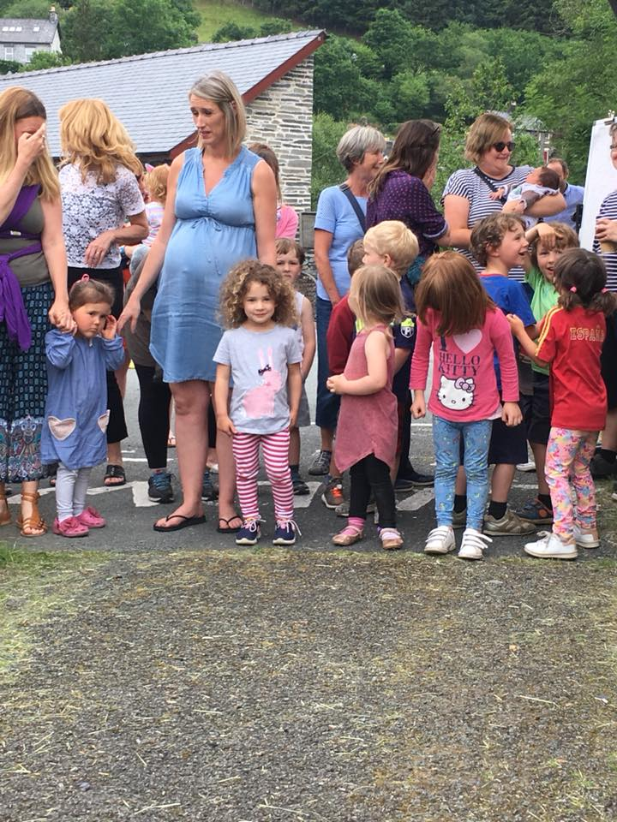**Admission to the Federation**

**When can my child start Nursery Education?**

**Part Time Pre School Nursery**

The Authority offers 10 hours a week of Nursery Education free of charge to children in the term following their third birthday for the remainder of the Academic year. The places are offered by partners in the voluntary and independent sectors who are registered with the EarlyYears and Child Care Partnership. A list of the providers is available by contacting the Manager of the Early Years Service on 01286 678824

**Part Time School Nursery Class**

The Authority offers children a part time (10 hours a week) nursery place in a school, in the September following their third birthday for a full academic year. Schools will normally have either a morning or an afternoon nursery session. In schools which have both morning and afternoon session there is no legal right for parents to choose which session their child attends. In the few areas where the Authority does not provide for the education of children in the September following their third birthday in a school, nursery provision is offered by funding places provided by the voluntary groups i.e. Mudiad Ysgolion Meithrin and Pre-School Playgroups. It should be noted that under Welsh Government rules a decision to admit a child to a nursery class does not guarantee or improve the chances of gaining a place in the reception class of that school. A separate application must be made.

**When can my child start school?**

**Full Time Reception Class**

The Authority offers children a full time place in a reception class in the September following their fourth birthday.Where a place is offered in the reception year parents have the option of deferring their child’s entry until later in the same school year up to the term following their child’s fifth birthday.

Admission may be granted to a school earlier than that offered under the admission policy in exceptional cases, which are referred for specific reasons in the context of the Children’s Act 1989 by:

(i) The Social Services or

(ii) The relevant Sector Medical Officer

It should be noted that under Welsh Government rules a decision to admit a child to a nursery class does not guarantee or improve the chances of gaining a place in the reception class of that school. A separate application must be made.

**How do I apply for a School place?**

The Education Department is the admissions authority of the community and voluntary controlled schools and is responsible for making decisions on admissions. Headteachers of these schools have no role in the admissions process and will not discuss the availability of places.All applications for admission must be submitted to the Authority in writing, using the forms provided (available at the schools or on [www.gwynedd.gov.uk/schooladmissions](http://www.gwynedd.gov.uk/schooladmissions) All decisions will also be given in writing. The Authority is not able to discuss the availability of places over the telephone. All preferences are treated equally.You are encouraged to state more than one preference.You may use a separate sheet to state more than three. If a place is available at more than one school, only the highest of your preferences available will be offered to you. If the Authority is unable to offer you any of your preferences, any new preferences received will be treated as late applications. The authority may not be able to offer places to late applicants if those schools are already full.**CHWARAEON**

Yn ogystal â chynnal Cwricwlwm statudol Addysg Gorfforol, bydd plant y Ffederasiwnyn cystadlu mewn rhaglen gynhwysfawr o athletau a mabolgampau yn erbyn plant yr ysgolion yn y dalgylch a thu hwnt.

Erbyn diwedd blwyddyn 6 mae’r Ffederasiwn yn annog plant i ymgyrraedd tuag at yr amcanion canlynol:

Dangos eu sgiliau, eu gwybodaeth a’u dealltwriaeth ar draws ystod o weithgareddau gyda rheolaeth a chywirdeb cyson. I ysgwyddo mwy o gyfrifoldeb dros eu dysgu eu hunain, ac i ofyn cwestiynau perthnasol er mwyn estyn a gwella eu perfformiad. Dechrau datblygu amrywiaeth gynyddol o syniadau dychmygus. Defnyddio egwyddorion cyfansoddi mewn gweithgareddau creadigol i gynllunio perfformiad gydag ymwybyddiaeth o’r ffactorau sy’n hybu ansawdd. Dechrau mireinio ac addasu tactegau, technegau a sgiliau a ddysgwyd yn flaenorol, a’u cymhwyso mewn sefyllfaoedd newydd. Gwrando’n ofalus ar eraill a defnyddio eu sylwadau i wella ansawdd eu perfformiad. Ysgwyddo mwy o gyfrifoldeb dros gynllunio elfennau o’u gwaith. Cymryd rhan mewn amrywiaeth o wahanol weithgareddau priodol sy’n cael effaith gadarnhaol ar eu hiechyd, a’u ffitrwydd.

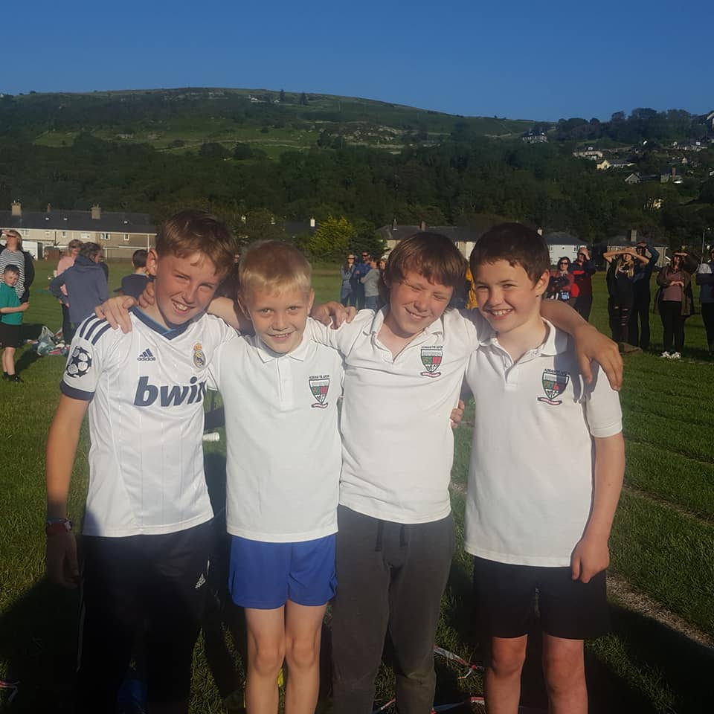

#### GAMES

In addition to providing the Statutory Aspects of the Physical Education Curriculum, the children of the Federation compete against the other schools in the catchment area, and further afield, in Athletics and Sports.

In lessons pupils strive to achieve the following (by the end of year 6):

Pupils demonstrate their skills, knowledge and understanding across a range of activities with consistent control and accuracy. Take increasing responsibility for their own learning, and ask relevant questions in order to extend and improve performance. Begin to develop an increasing variety of imaginative ideas. Use compositional principles in creative activities to plan a performance with an awareness of the factors that promote quality. Begin to refine and adapt previously learned tactics, techniques and skills and apply them in new situations. Listen carefully to what others say about their work and use their observations to improve the effectiveness and quality of their own and others’ performances. Increasingly, take responsibility for the planning of elements of their work. Engage in a variety of appropriate, different activities that positively affect their health, fitness and feelings about themselves.

|  |  |
| --- | --- |
| **Dyffryn Dulas** | |
| Esgidiau du | Black shoes |
| Trowsus du / llwyd | Black / grey trousers |
| Sgert ddu / llwyd | Black / grey skirt |
| Crys polo gwyn | White polo shirt |
| Crys chwys marŵn | Maroon sweatshirt |
| Treinyrs, siorts a chrys chwys i wersi addysg gorfforol | Trainers, shorts and a teeshirt for PE lessons |

|  |  |
| --- | --- |
| **Pennal** | |
| Esgidiau du | Black shoes |
| Trowsus du / llwyd | Black / grey trousers |
| Sgert ddu / llwyd | Black / grey skirt |
| Crys polo gwyn | White polo shirt |
| Crys chwys jêd | Jade sweatshirt |
| Treinyrs, siorts a chrys chwys i wersi addysg gorfforol | Trainers, shorts and a teeshirt for PE lessons |

**GWISG YSGOL**

Mae gan y ddwy ysgol wisg swyddogol a disgwylir i’r plant ei gwisgo

**bob dydd**. Gellir prynu crys polo a chrys chwys drwy’r ysgol.

**Er mwyn hwylustod, gofynnir i rieni roi enw ar ddillad**

**SCHOOL UNIFORM**

Both schools have an official school uniform, and children are expected to wear it every day. Polo shirts and sweatshirts can be purchased through the school.

**Parents are kindly asked to label children’s clothes.**

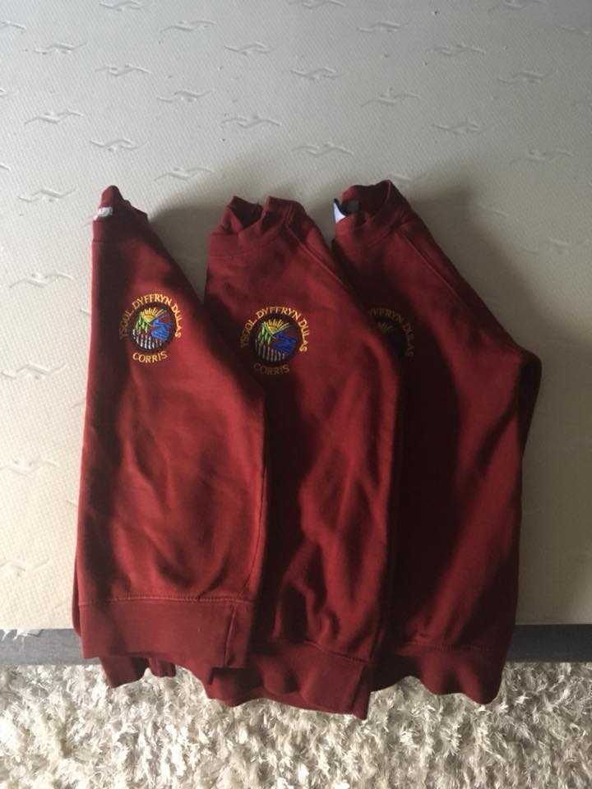

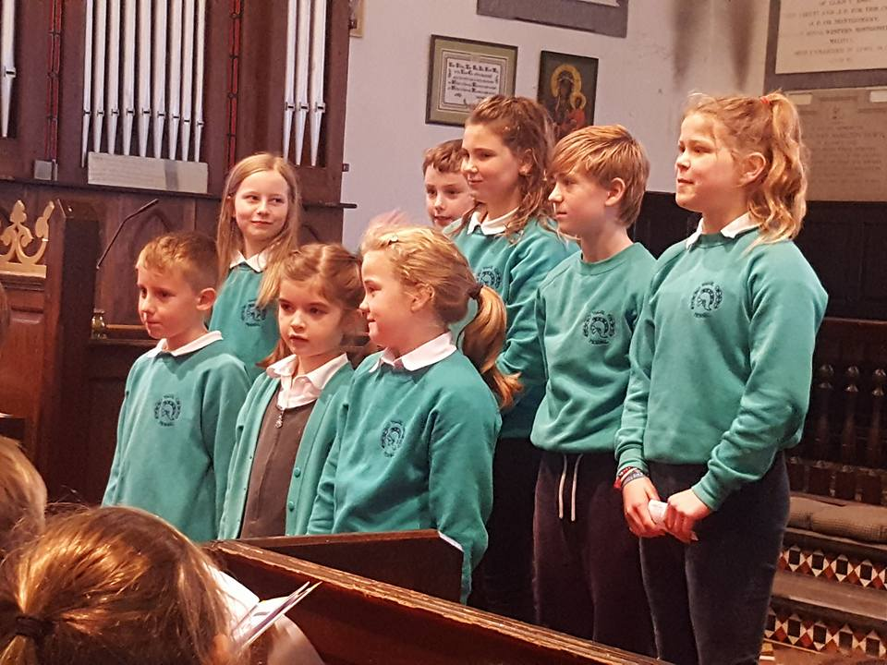

**LLAETH / MILK**

Caiff plant 3 – 7 oed laeth am ddim yn ddyddiol ac fe gynigir llaeth i’r plant hynaf am 10c y dydd.

3 – 7 year olds are given milk daily, free of charge. The older pupils may opt to purchase milk for 10p per day.

**FFRWYTH / FRUIT**

Annogir plant y Ffederasiwn i fwyta ffrwythau yn ddyddiol ac i ddod a ffrwyth i’r ysgol gyda hwy.

Children are encouraged to eat at least one piece of fruit every day and to bring their own fruit to school.

**DOGFENNAU**

Petai unrhyw riant yn dymuno gweld cynlluniau gwaith, polisïau neu ddogfennau perthnasol eraill, yna mae croeso iddo/iddi gysylltu â’r pennaeth ymlaen llaw i drefnu dyddiad ac amser cyfleus i ddod i’r ysgol i’w gweld. Codir ffi am lungopio.

#### DOCUMENTS

If parents request to see schemes of work, policies or any other relevant documents, then he/she is welcome to contact the headteacher, in order to arrange a convenient date and time to visit the school to view them. Photocopying charges apply.

**TREFN DIOGELU AC AMDDIFFYN PLANT**

Mae pob aelod o staff y Ffederasiwn yn gyfrifol am ddiogelu ac amddiffyn y plant

sy’n ei mynychu. Os ceir pryderon ynglŷn ag esgeulustra neu gam-drin corfforol,

emosiynol neu rywiol, yna mae’n ddyletswydd ar y staff, yn unol â Chanllawiau

Amddiffyn Plant Cymru Gyfan 2008, i sôn am y mater wrth Gyd-gysylltydd Diogelu

Plant yr Ysgol.

Gall Cyd-gysylltydd yr ysgol ymgynghori â chyd-weithwyr proffesiynol yn ogystal

ag asiantaethau perthnasol megis y Gwasanaethau Iechyd a Chymdeithasol. Yn dilyn y trafodaethau hyn, efallai y bydd rhaid i gyd-gysylltydd y Ffederasiwn gyfeirio’r plentyn yn swyddogol at yr Adran Gwasanaethau Cymdeithasol, yn unol â chanllawiau a phrotocol y sir. Yr Adran Gwasanaethau Cymdeithasol sy’n penderfynu a oes angen gweithredu neu beidio.

Oblegid natur y cyhuddiadau, ni fydd bob amser yn briodol i drafod materion gyda rhieni cyn cyfeirio’r plentyn. Y Gwasanaethau Cymdeithasol a’r Heddlu sy’n gyfrifol am ymchwilio i gyhuddiadau.

**Y Pennaeth Mrs H L N Jones yw Cyd-gysylltydd Diogelu Plant y Ffederasiwn, ac yn ei habsenoldeb Mrs K Lockett / Miss E Wyn Jones / Mrs Nia Rowlands**

**Y Llywodraethwr gyda chyfrifoldeb am ddiogelu plant yw Mrs A O Roberts.**

**CHILD PROTECTION PROCEDURES**

All members of staff are responsible for the safety and protection of the children who attend the Federation. If there are concerns regarding neglect or physical, emotional or sexual abuse then, under the County’s Child Protection Procedures, staff are duty bound to report the matter to the school’s Child Protection Co-ordinator. The school’s Co-ordinator may consult with professional colleagues as well as relevant agencies such as Health and Social Services. Following these discussions the school’s co-ordinator may be obliged to make an official referral to the Social Services Department in accordance with county guidelines and protocol. It is the Social Services Department who decides on the next course of action. Due to the nature of the allegations it may not always be appropriate to discuss matters with parents prior to making a referral. The responsibility for investigating allegations lies with Social Services and the Police.

**The Headteacher, Mrs Helen Jones is the Federation’s Child Protection Co-ordinator, and in her absence Mrs K Lockett / Miss E Wyn Jones / Mrs Nia Rowlands**

**The Governor responsible for Child Protection is Mrs A O Roberts.**

**GWEITHDREFNAU CWYNO CYRFF LLYWODRAETHU YSGOLION**

Mae’r gweithdrefnau hyn yn cael eu rheoli gan Gylchlythyr Cynulliad Cenedlaethol Cymru Rhif 03/2004

* Os oes unrhyw un am wneud cwyn swyddogol yn erbyn aelod o’r staff, dylid gwneud hynny i’r pennaeth
* Os oes unrhyw un am wneud cwyn swyddogol yn erbyn y pennaeth, dylid gwneud y gwyn i Gadeirydd y Corff Llywodraethol
* Os oes unrhyw un am wneud cwyn swyddogol yn erbyn aelod o’r Corff Llywodraethol dylid gwneud hynny i Gadeirydd y Corff Llywodraethol neu i’r Is-gadeirydd os yw’r gwyn yn erbyn y Cadeirydd.
* Mae Polisi Cwynion yn yr ysgol a gellir gofyn i’w weld.

**SCHOOL GOVERNING BODY COMPLAINTS PROCEDURE**

These procedures are governed by National Assembly for Wales Circular No: 03/2004.

* Any formal complaint about a member of staff should be made to the Head-teacher
* Any formal complaint about the Head-teacher should be made to the Chair of Governors.
* Any formal complaint about a member of the School Governors should be made to the Chair of Governors or Vice-chair in the case of a complaint against the Chair of Governors.
* The policy can be obtained from the headteacher and rea at school.

**TREFNIADAU AR GYFER GWNEUD CWYNION AM Y CWRICWLWM**

Mae’r Awdurdod Addysg Lleol, yn unol â gofynion statudol, wedi sefydlu trefn i ystyried cwynion am y modd y mae cyrff llywodraethu’r ysgol a’r Awdurdod Addysg yn gweithredu mewn perthynas a chwricwlwm ysgol a materion eraill cysylltiedig. Mae’r drefn hon wedi ei hamlinellu mewn dogfen bwrpasol yn y Gymraeg a’r Saesneg sydd ar gael i unrhyw riant sy’n dymuno gwneud cwyn dan y trefniadau hyn, a gall yr Awdurdod ddarparu copi mewn iaith heblaw’r Gymraeg a’r Saesneg os bydd hynny’n angenrheidiol. Pwysleisir, fodd bynnag, y gellir ymdrin a llawer o gwynion yn gyflym ac effeithiol drwy ystyriaeth anffurfiol yn seiliedig ar drafodaethau gyda’r Prifathro. Hwn yw’r cam rhesymol cyntaf, a bydd y Corff Llywodraethu’n disgwyl bod y cam yma wedi ei gyflawni cyn cyflwyno’r gwyn yn ffurfiol mewn achosion eithriadol.

Dylid cysylltu â’r ysgol i wneud apwyntiad i drafod unrhyw gwyn gyda’r Prifathro.

Atgoffir rhieni ei bod yn bosibl gweld copïau o unrhyw offeryn statudol a chylchlythyron a anfonir i ysgolion gan y Swyddfa Gymreig ynghylch pwerau a dyletswyddau cyrff llywodraethu o dan Bennod 1 Rhan 1 Deddf Diwygio Addysg.

**ARRANGEMENTS FOR LODGING COMPLAINTS ABOUT THE CURRICULUM**

The Local Education Authority, in accordance with statutory requirements, has established a procedure to consider complaints about how school governing bodies and the Education Authority act as regards the school curriculum and other associated matters. An outline of this procedure is given in a purposive document in Welsh and English that any parent wishing to lodge a complaint under these arrangements may examine, and the Authority can provide a copy in a language other than Welsh and English if required. It is emphasised, however, that many complaints may be dealt with both quickly and effectively through informal consideration based on discussions with the Headteacher. This is the initial reasonable step that should be taken, and the Governing Body expects this step to have been taken before the complaint is formally lodged in exception cases.

The school should be contacted in order to discuss any complaints with the Headteacher.

Parents are reminded that copies of any statutory instruments and any Welsh Office circulars sent to schools regarding the powers and responsibilities of governing bodies under Chapter 1 Section 1 of the Education Reform Act are available for inspection.

**POLISI IAITH**

**AMCANION CYFFREDINOL**

Mae Awdurdod Addysg Gwynedd yn gweithredu polisi ddwyieithog trwy holl ysgolion Gwynedd ac hefyd yn datblygu polisi dwyieithog ar gyfer sefydliadau Addysg Bellach.

Yr amcan yw datblygu gallu disgyblion a myfyrwyr y sir i fod yn hyderus ddwyieithog er mwyn eu galluogi i fod yn aelodau cyflawn o'r gymdeithas ddwyieithog y maent yn rhan ohoni.

Dylai holl sefydliadau addysg y sir adlewyrchu ac atgyfnerthu'r polisi iaith yn eu gweinyddiad, eu bywyd cymdeithasol a'u trefn fugeiliol yn ogystal ag yn eu darpariaeth academaidd.

**AMCANION PENODOL**

**Addysg Feithrin**

Sicrhau, trwy ddarpariaeth a threfniadaeth feithrin bwrpasol a sensitif, y rhoddir i bob plentyn sylfaen gadarn yn y Gymraeg er mwyn ei alluogi i gyrraedd y nôd o ddwyieithrwydd llawn maes o law.

**Y Cyfnod Sylfaen**

Adeiladu ar y sylfeini a osodwyd i'r Gymraeg drwy addysg feithrin. Cadarnhau a datblygu mamiaith y plentyn o ddysgwyr Cymraeg ac ymestyn gafael y plentyn o gartref Cymraeg ar y Saesneg.

**Cyfnod Allweddol 2**

Cadarnhau datblygu Cymraeg a Saesneg pob plentyn yn eu holl agweddau goddefol a gweithredol, er mwyn sicrhau ei fod yn gallu siarad, darllen ac ysgrifennu'n rhwydd ac yn hyderus yn y ddwy iaith pan fo'n trosglwyddo i'r ysgol uwchradd. Gwneir darpariaeth arbennig ar gyfer hwyr-ddyfodiaid.

**Siarter Iaith Gymraeg Ysgolion Cynradd Gwynedd**

Mae’r Ffederasiwn wedi ymrwymo yn llawn i Siarter Iaith Gymraeg Ysgolion Cynradd Gwynedd. Mae Siarter Iaith Gymraeg Ysgolion Cynradd Gwynedd yn deillio o waith manwl y Gweithgor Dylanwadu ar Ddefnydd Cymdeithasol Plant o’r Gymraeg. Ei phrif ddiben yw sicrhau bod y Gymraeg, a defnydd cymdeithasol ein plant a phobl ifanc ohoni yn ffynnu. Defnyddir saith nôd y siarter fel offerynnau i fesur cynnydd yn y defnydd o’r iaith ynghyd â llwyddiant cynlluniau ein hysgolion.

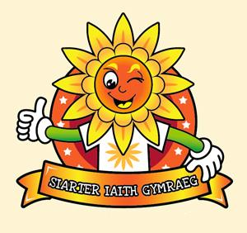

**LANGUAGE POLICY**

**GENERAL AIMS**

Gwynedd Education Authority operates a bilingual policy in all its schools and is also developing a bilingual policy for the Further Education establishments within the county.

The aim is to develop the ability of pupils and students within the county to be confidently bilingual in order that they can be full members of the bilingual society of which they are a part.

All educational establishments within the county should reflect and reinforce the language policy in their administration, their social life and pastoral arrangements as well as their academic provision.

**SPECIFIC AIMS**

**Nursery**

To ensure, through sensitively structured provision and organisation, that each child receives a firm foundation in Welsh in order to enable him/her in due course to attain the aim of full bilingualism.

**The Foundation Phase**

To build on the Welsh language foundation laid through nursery education, to consolidate and develop the mother tongue of children who are Welsh learners and extend the children from a Welsh speaking home's competence in English.

**Key Stage 2**

To consolidate and develop each child's Welsh and English capabilities in all aspects, both active and receptive, so as to ensure that he/she can speak, read and write fluently and confidently in both languages on transferring to the secondary school. (Special provision will be made for junior late-comers).

**Siarter Iaith Gymraeg Ysgolion Cynradd Gwynedd**

The Federation is fully committed to Gwynedd Primary Schools Welsh Language Charter. The Welsh Language Charter derives from research of the Working Group into the Influence of Social Settings and the Use of the Welsh Language. Its main purpose is to ensure that the Welsh language and social needs of our children and young people today are thriving.



#### CODI TÂL AM YMWELIADAU ADDYSGOL

Ymdrechir i alluogi pob plentyn i fod yn rhan o ymweliadau all-gwricwlaidd y Ffederasiwn. Gofynnir am gyfraniad ariannol tuag at gost unrhyw ymweliad.

Petai unrhyw riant yn teimlo ei bod hi’n anodd cyfrannu yn ariannol, mae croeso iddynt gysylltu â’r ysgol i drafod y mater yn gyfrinachol. Gall yr ysgol wedyn gynnig eu cynorthwyo.

Codi’r tâl rhannol am wersi offerynnol cerdd.

Wrth weithredu’r polisi yma gobeithir y gall pob plentyn dderbyn y profiadau amrywiol sy’n cael eu cynnig.

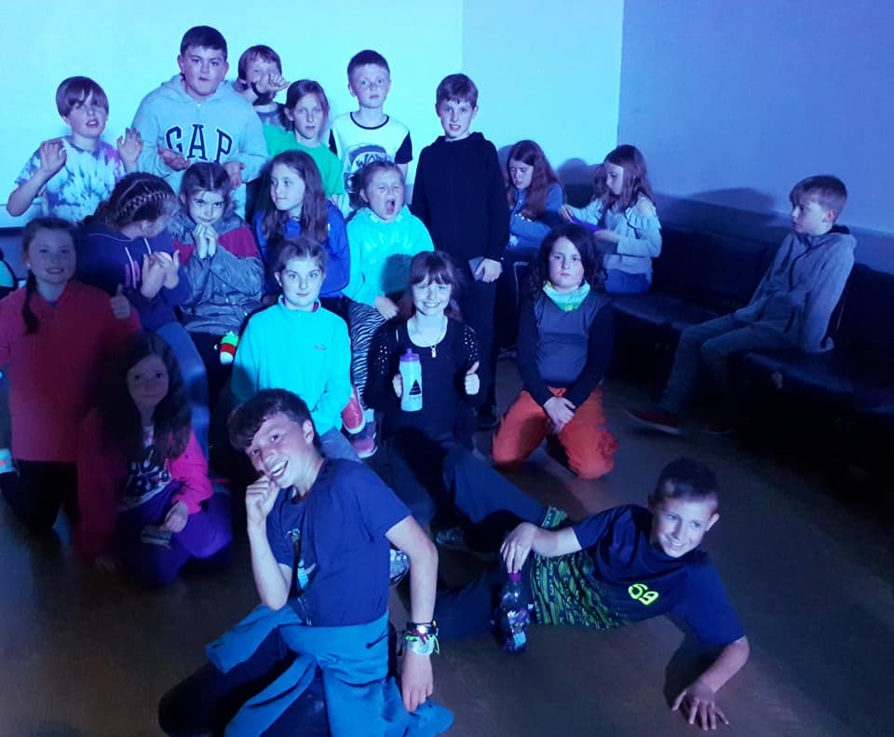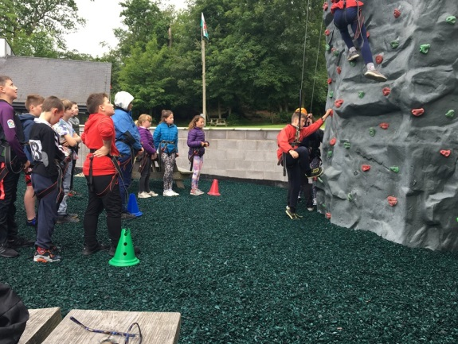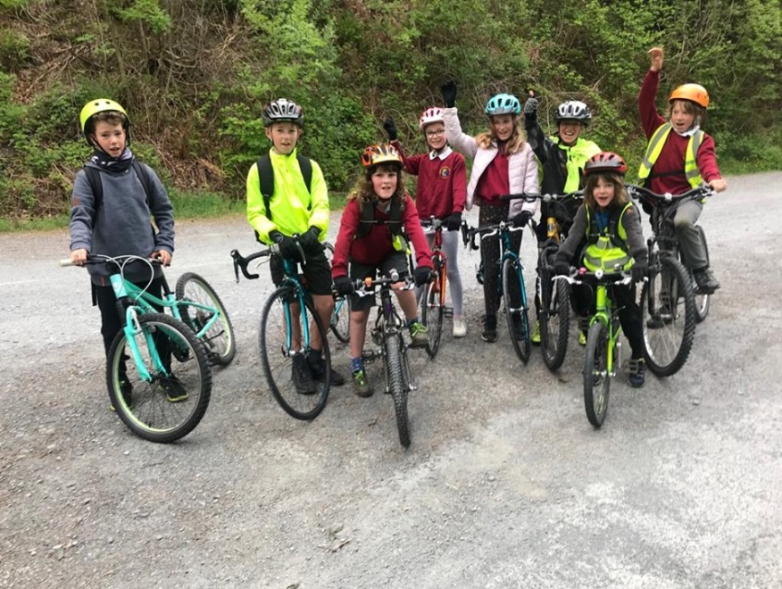

#### CHANGING FOR EDUCATIONAL ACTIVITIES

The Federation’s aim is to enable each child to take part in the school’s curricular and extracurricular activities. On some occasions parents are asked to contribute a sum of money to help meet the cost of a particular visit.

If a parent has difficulty in contributing financially, then they are welcome to contact the school to discuss the matter in confidence. The school may then assist them with a contribution.

A fractional charge is imposed for instrumental lessons.

By implementing this policy, every child will be able to benefit from the variety of activities that are on offer.

**DISGWYLIADAU YR YSGOL / THE SCHOOL’S EXPECTATIONS**

1. Dylid trefnu ymlaen llaw gyda’r pennaeth / athrawon ym mhob achos.

*Please contact the headteacher / teachers to arrange a meeting beforehand.*

1. Disgwylir i bob plentyn fynychu’r ysgol yn rheolaidd. Pan fo rheswm anorfod dros absenoldeb dylid hysbysu’r ysgol trwy lythyr, ebost neu alwad ffôn ar y bore cyntaf. Mae hyn yn bwysig gan fod y Swyddfa Gymreig yn gofyn i ysgolion am fanylion absenoldebau.

*Every child is expected to attend school regularly. When an absence is unavoidable the school should be notified on the first morning. This is important as the Welsh Office now gathers information regarding absences from schools.*

1. Disgwylir i bob plentyn fod yn yr ysgol erbyn 9.00yb

*Every child is expected to be in school by 9.00am*

1. Ceisir meithrin yn y plant yr arfer o fod yn gyfrifol am eu heiddo personol, ac ni ddylid gadael eiddo gwerthfawr mewn pocedi cotiau, bagiau ac yn y blaen.

*We endeavour to develop in the children the habit of assuming responsibility for their own belongings, and no valuables should be left in coat pockets, bags etc.*

1. Fe geisir cysylltu â rhieni ar unwaith os credir fod angen gwneud hynny, e.e. mewn achos o fân ddamweiniau neu salwch. Cyfrifoldeb y cartref yw gofalu fod yr ysgol yn cael gwybod am unrhyw newid i gyfeiriad / cyfeiriad ebost / rhif ffôn / newidiadau i amgylchiadau yn y cartref e.e. pwy sydd yn gyfrifol am nôl y plant o’r ysgol am 3.30 ayb

*We endeavour to contact parents at once if it is deemed necessary - in cases*

*of minor accidents or illness. However, it is the parent’s responsibility to keep the*

*school informed of any changes to address/telephone number/ email address /*

*parental responsibility/authorised people to collect children from school etc.*

1. Ni chaniateir i blentyn fynd y tu allan i derfynnau’r ysgol yn ystod oriau’r ysgol heb ganiatâd y pennaeth.

*Children are not permitted to leave school premises during school hours without the Head teacher’s consent.*

1. Rhaid talu ar lein am ginio ysgol.

*Dinner money is payed online*

1. Am resymau diogelwch ni chaniateir i ddisgyblion wisgo clust-dlysau sydd yn hongian.

*For reasons of safetly children are not permitted to wear earrings that dangle.*

1. Ni fydd staff yr ysgol yn gyfrifol am ddiogelwch y plant yn yr ysgol cyn 8.50a.m. ac ar ôl 3.40p.m. (Onibai fod y plant yn mynychu clwb)

*The school staff will not be responsible for the safety of the children before 8.50a.m. and after 3.40p.m.(Other than the children that attending a club)*

1. Os oes oedolyn gwahanol i’r arfer yn dod i nôl plentyn o’r ysgol dylid rhoi gwybodaeth am hynny gan rieni i athrawon yr ysgol. Dylid rhoi gwybod i’r athrawon petai newid yn y drefn arferol am ddiwrnod yn unig.

Ni chaniateir i blentyn fynd gartref o’r ysgol gyda ffrind heb wybodaeth ymlaen llaw gan rieni.

If another person comes to collect the child from school, parents should notify

teachers. Teachers should be notified if there is a different arrangement even for

one day.

*Children are not allowed to go home from school with a friend, without parent*

*giving the school prior notice.*

1. Ni chaniateir i rieni ddod â char ar dir yr ysgol.

*Parents are not permitted to drive their cars through the main gates onto the*

*School’s grounds*

1. Ni chaniateir i blant fwyta fferins, pop a.y.y.b.

*Sweets and pop etc are not permitted.*

**POLISI ABSENOLDEB**

Mae bod yn absennol o’r ysgol yn mynd i effeithio ar gynnydd disgybl. Bydd hefyd yn effeithio ar addysg gweddill y plant sydd yn yr ysgol gan y gall ddal gwaith y grp neu’r dosbarth yn ôl pan fydd y plant a fu yn absennol yn dychwelyd. Wrth gwrs, bydd unrhyw absenoldeb yn gwneud hi’n anodd i’r athro/athrawes i sicrhau dilyniant a datblygiad yn strwythur y gwaith gan y bydd unigolion yn colli agweddau pwysig o’r gwaith.

Felly, mae hi’n holl bwysig i blant fynychu yr ysgol bob amser, ac mae hi’n gyfrifoldeb statudol ar y Llywodraethwyr i sicrhau hynny.

## Absenoldebau

Mae pob absenoldeb naill ai yn un awdurdodedig neu yn un anawdurdodedig. Dim ond yr ysgol sydd â’r hawl i awdurdodi absenoldeb, a gall hyn gynnwys salwch, apwyntiadau deintyddol neu amgylchiadau na fedrir eu rhagweld.

Absenoldebau anawdurdodedig fydd y gweddill.

**Gwyliau Teuluol**

Fel mae’r ddeddf yn sefyll, **nid oes gan rieni hawl i dynnu eu plant o’r ysgol er mwyn mynd ar wyliau yn ystod y tymor**. Mae gan Lywodraethwyr ysgolion yr hawl i ganiatáu neu i wrthod ceisiadau. Teimlad cryf Llywodraethwyr y Ffederasiwn yw na ddylai rhieni fynd â’u plant ar wyliau yn ystod y tymor. Ond, penderfynwyd ein bod yn fodlon ystyried unrhyw **gais ysgrifenedig ymlaen llaw i deulu gymeryd i fyny at uchafswm o 10 diwrnod ysgol yn unig mewn blwyddyn ysgol.** Yn ddelfrydol, ac os oes gwir angen, efallai y dylid ystyried y 10 diwrnod hynny yn ystod wythnos olaf y tymor, neu i fod ynghlwm a hanner tymor.

Os caniateir yr absenoldeb, yna ystyrier o fel un awdurdodedig.

Os na fydd y plentyn wedi dychwelyd i’r ysgol ar y 11eg diwrnod ysgol, yna absenoldeb anawdurdodedig fydd o, oni bai fod yna esboniad derbyniol.

Bydd yr absenoldeb anawdurdodedig yn caniatáu yr ysgol i weithredu fel a ganlyn

a) trosglwyddo’r wybodaeth i sylw Swyddog Lles y Sir. Bydd ef/hi wedyn yn penderfynu pa gamau fydd angen eu cymeryd ymhellach.

b) petai’r plentyn ddim yn dychwelyd am 10 diwrnod, yna byddwn yn medru dileu enw’r plentyn o gofrestr yr ysgol.

### Apwyntiadau Meddygol/Deintyddol

Gofynnir i rieni i geisio cael apwyntiadau deintyddol, optegyddol a meddygol, heblaw mewn argyfwng, naill ai ar ôl oriau ysgol neu yn ystod y gwyliau.

## Disgyblion yn Hwyr

Cofnodir disgyblion nad ydynt yn yr ysgol erbyn 9.00 yn absennol – anawdurdodedig – am weddill y bore. Gall nifer o absenoldebau cyffelyb arwain yr ysgol i dynnu sylw y Swyddog Lles at y mater.

## Cyffredinol

Gofynnir i rieni gysylltu â’r ysgol erbyn 9.00 os bydd eu plant yn absennol y diwrnod hwnnw. Mae hyn hefyd am resymau diogelwch, oherwydd gall plentyn fod wedi cychwyn am yr ysgol ac eto heb gyrraedd. Ni fydd y rhieni yn gwybod, a hwyrach ni fydd yr ysgol yn ei ddisgwyl chwaith. Petai’r absenoldeb yn parhau mwy na diwrnod, yna’n hytrach na chysylltu â’r ysgol bob bore, gall y rhieni roi gwybod i’r ysgol ar y bore fydd y plentyn yn dychwelyd.

**ABSENCE POLICY**

## Introduction

Any absence from school, for whatever reason, will affect a pupil’s progress. Needless to say, this will make it difficult for the teacher to ensure continuity in the work as children will be missing the beginning or other aspects of a particular programme of work.

Therefore, it is of paramount importance for children attend school at all times and it’s a statutory duty of the Governors to ensure so.

## Absences

All absences are either authorised or unauthorised. Only the school can authorise an absence, which covers illness, dental appointments or other possible unforeseen circumstances. Other absences are unauthorised.

## Family Holidays

Parents, **by law, have no right to withdraw their children from school to go on holiday.** The Governors of schools have the discretion to allow such holidays or not. The Governors of this Federation strongly disapprove of any child being withdrawn from school to go on a family holiday during term time. But consideration will be given to a **written request beforehand to take up to a maximum of 10 school days per school year**. Ideally, and if necessary, those 10 days should be taken during the last week of a term, or possibly attach them to half term.

If permission is granted, then those 10 days will be classified as an authorised absence.

If a child has not returned to school on the 11th school day, then that absence will be unauthorised, unless there is an acceptable explanation for the absence.

The unauthorised absence will allow the school to take the following steps.

a) Report the absence to the County’s Welfare Officer, who will then take the appropriate action he/she feels necessary.

b) If the child has still not returned to school after 10 days, the school can then remove the child’s name from the register.

### Medical/Dental Appointments

Parents are requested to try and ensure that dental, optician, and medical appointments, except for emergencies, are made either during the school holidays or after school hours.

## Pupils Late for School

Pupils who are not at school by 9.00 in the morning will be recorded as being absent – unauthorised – for the whole morning session. A number of such absences could then lead the school to report the matter to the Welfare Officer.

**General**

Parents are requested to contact the school by 9.00 a.m. if a child will be absent that day. This is for safety reasons as well, because a child may have left home for school and may not arrive.

**MYNEDIAD I’R CWRICWLWM AC INTEGREIDDIO**

Yn dilyn Deddf Addysg 1981 ceisir integreiddio plant ac arnynt AAA a’u cynnwys o fewn dosbarthiadau arferol yr ysgolion pan fo hynny’n ymarferol bosibl. Mae plant sydd â datganiad arnynt yn arferol yn cael cyfnodau o fewn unedau arbennig ac yn derbyn cynhaliaeth bellach am gyfnodau yn eu hysgolion gan athrawes yr uned.

Derbynnir yn gyffredinol fod tua 5% o ddisgyblion am fod ag AAA ar ryw adeg o’u gyrfa addysgol a bod hyn yn cynnwys anghenion arbennig amrywiol. Tua 2% o blant fydd ar ddatganiad.

Bydd y plant ar Gyfnod 1 yn cymysgu’n llwyr a gweddill o blant y dosbarth ym mhob agwedd o’r cwricwlwm.

Byddwn yn rhoi cylfe i blant AAA ar ba gyfnod bynnag ddilyn y Cwricwlwm Cenedlaethol ar lefel a chyflymdra sydd yn addas iddynt hwy.

Dibynna hyn o reidrwydd ar natur anawsterau plentyn unigol. Cyn belled a bo’n rhesymol ymarferol bydd y plant yma yn ymuno hefyd yn holl weithgareddau arferol yr ysgol megis ymweliadau addysgol a chynhyrchiadau cyhoeddus.

Byddwn yn ymateb gyda sensitifrwydd i broblemau dysgu y plentyn gyda AAA a gwneud pob ymdrech i geisio codi ei hunan barch.

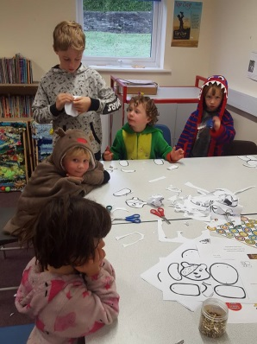

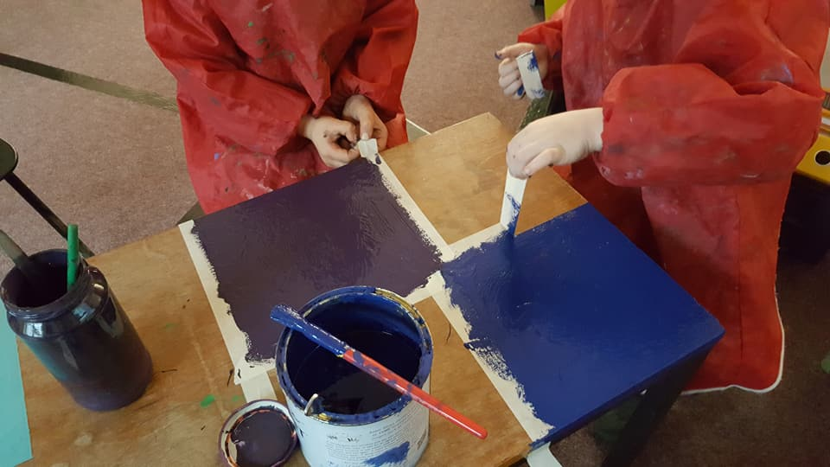

**ACCESS TO THE CURRICULUM AND INTEGRATION**

As a result of the Education Act 1981, an attempt is made to integrate children with SEN and include them in regular school classes, wherever practicable. Statemented children usually spend time in special units and receive further support for periods in their own schools from the unit teacher.

It is generally accepted that approximately 5% of pupils will have SEN at some time during their educational careers and that this contains various aspects of special needs. Around 2% of children will be statemented.

Children on Stage 1 will fully integrate with other children in class in all aspects of the curriculum.

We will provide SEN children, whatever stage they are on, with the opportunity to follow the National Curriculum at a level and pace which suits them.

This depends, inevitably, on the nature of the individual child’s difficulties. As far as is reasonably practicable, these children will also participate in all the usual school activities such as educational visits and public events.

We will respond sensitively to the learning difficulties of a child with SEN and endeavour to increase his/her self-respect.

**ANGHENION DYSGU YCHWANEGOL**

**Mrs Kayla Lockett** yw cydlyndd ADY y Ffederasiwn a **Mrs A O Roberts** yw’r Llywodraethwraig dynodedig.

Gall darpariaeth ar gyfer plant ADY amrywio: rhoddir sylw unigol/grŵp bychan o blant o fewn y dosbarth gan yr athrawon dosbarth. Os oes angen mwy o sylw unigol cyfeirir y plentyn i sylw Adran Gwasanaeth Seicolegol y Sir gyda’r posibilrwydd o drefnu darpariaeth arbenigol.

**POLISI ANGHENION DYSGU YCHWANEGOL**

Ein nod yw datblygu dulliau o asesu manwl er mwyn adnabod anghenion penodol pob plentyn a threfnu rhaglen waith berthnasol ar ei gyfer. Mae’r Ffederasiwn hefyd yn ystyried disgyblion talentog neu sydd â gallu arbennig fel unigolion sydd ag Anghenion Dysgu Ychwanegol. Rhoddir enw pob plentyn ag Anghenion Dysgu Ychwanegol ar Gofrestr A.D.Y. Y Ffederasiwn sy’n gyfrifol am leoli plant ar y camau a nodir yng ‘Nghod Ymarfer Anghenion Dysgu ychwanegol Cymru’ ac am fonitro, adolygu ac am ddyrannu adnoddau ar eu cyfer o gyllid yr ysgol. Yr Awdurdod sy’n gyfrifol am roi Datganiad Anghenion Dysgu Ychwanegol i blentyn. Mae’n bolisi gan y Ffederasiwn i gysylltu â rhieni unrhyw blentyn pan fydd yn cael ei osod mewn unrhyw gyfnod a/neu cyn iddo gael ei gyfeirio am asesiad arferol neu statudol. Cedwir mewn cysylltiad ynglŷn â chynnydd y plentyn a gwahoddir y rhieni i bob adolygiad. Gellir gweld copi llawn o’r polisi Anghenion Dysgu Ychwanegol yn yr ysgol.

**ADDITIONAL LEARNING NEEDS**

**Mrs Kayla Lockett** is the Federation’s ALN co-ordinator and **Mrs A O Roberts** is the designated governor.

Support varies: Individual attention or small group attention is given within the class by the class teacher. If extra individual attention is required, the child is then referred to the County Psychological Service Department, where specialist provision could be arranged.

**ADDITIONAL LEARNING NEEDS POLICY** Our aim is to develop a comprehensive and detailed means of assessment in order to identify each pupil’s specific needs and to devise a work schedule that is relevant to that pupil. The school also considers talented pupils or those with a special ability as individuals with Additional Learning Needs. Every child with Additional Education Needs is included on the Additional Needs Register. It is the Federation’s responsibility to place children in the stages described in the ‘Welsh Additional Learning Needs Code of Practice’, and to monitor, review and allocate resources for this purpose out of the school budget. It is the Authority’s responsibility to provide a child with a Statement of Additional Educational Needs. It is the Federation’s policy to consult with parents when a child is placed in any stage and/or referred for a usual or statutory assessment. We keep parents fully informed of any improvement in the child, and they are invited to every review. A full copy of the Additional Learning Needs policy can be seen at the school.

|  |  |  |  |  |  |  |  |  |  |  |  |  |  |  |  |  |  |  |  |  |  |  |  |
| --- | --- | --- | --- | --- | --- | --- | --- | --- | --- | --- | --- | --- | --- | --- | --- | --- | --- | --- | --- | --- | --- | --- | --- |
| **Presenoldeb Ysgol Dyffryn Dulas Corris Attendance**  **01/09/2003 - 31/08/2014**   |  | **Nifer plant / No of Pupils** | **Absenoldebau awdurdodedig**  **Authorised Absences** | | | **Absenoldeb anawdurdodedig**  **Unauthorised Absences** | | | | --- | --- | --- | --- | --- | --- | --- | --- | | **Nifer plant /**  **No of Pupils** | **% o blant/**  **% of Pupils** | **% o sesiynau/**  **% of Sessions** | **Nifer plant /**  **No of Pupils** | **% o blant/**  **% of Pupils** | **% o sesiynau/**  **% of Sessions** | | **Cyfanswm**  **Totals** | 58 | 54 | 93.1 | 4.6 | 3 | 5.2 | 0.0 |  |  | | --- | |  | |

**Presenoldeb Ysgol Pennal Attendance**

**01/09/2003 - 31/08/2014**



|  |
| --- |
|  |

|  | **Nifer plant / No of Pupils** | **Absenoldebau awdurdodedig**  **Authorised Absences** | | | **Absenoldeb anawdurdodedig**  **Unauthorised Absences** | | |
| --- | --- | --- | --- | --- | --- | --- | --- |
| **Nifer plant /**  **No of Pupils** | **% o blant/**  **% of Pupils** | **% o sesiynau/**  **% of Sessions** | **Nifer plant /**  **No of Pupils** | **% o blant/**  **% of Pupils** | **% o sesiynau/**  **% of Sessions** |
| **Cyfanswm**  **Totals** | 16 | 14 | 87.5 | 6.0 | 0 | 0.0 | 0.0 |

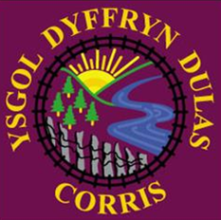**CANLYNIADAU 2019**

**Perfformiad Asesiadau Athrawon ar Ddiwedd Cyfnodau allweddol**

**Teacher Assessment at the end of Key Stages**

**Ysgol Dyffryn Dulas Corris**

**Canlyniadau diwedd Cyfnod Allweddol 2 / Endof Key Stage 2 Results**

|  |  |  |  |  |
| --- | --- | --- | --- | --- |
|  | Canlyniadau 2019 Results | | | 2018 |
| Pwnc / Subject | L4+ (Bechgyn / Boys) 5 | L4+ (Merched / Girls) 3 | L4+ (Disgyblion / Pupils) 8 | L4+ (Cymru / Wales) |
| Saesneg  English | 80% | 66.6% | 75% |  |
| Cymraeg  Welsh | 80% | 66.6% | 75% |  |
| Mathemateg  Maths | 100% | 66.6% | 88% |  |
| Gwyddoniaeth  Science | 80% | 66.6% | 75% |  |
| Dangosydd Pynciau Craidd  Core Subject Indicator | 80% | 66.6% | 86% |  |

**Canlyniadau diwedd Cyfnod Sylfaen (Blwyddyn 2) / Endof Foundation Phase Results (Year 2)**

**Deilliant 5+ / Outcome 5+**

|  |  |  |  |  |
| --- | --- | --- | --- | --- |
|  | Canlyniadau 2019 Results | | | 2018 |
| Pwnc / Subject | Deilliant 5+  Outcome 5+  (bechgyn / boys) | Deilliant 5+  Outcome 5+ (merched / girls) | Deilliant 5+  Outcome 5+  (disgyblion / pupils) | Deilliant 5+  Outcome 5+ (Cymru / Wales) |
| Dat Cymraeg  Welsh | 50% | 0 | 25% |  |
| Dat Mathemateg  Maths | 66.6% | 100% | 75% |  |
| Datblygiad Personol a Chymdeithasol  Personal and Social Development | 83% | 100% | 75% |  |
| Dangosydd Cyfnod Sylfaen  Foundation Phase Indicator | 33.3% | 0% | 25% |  |



**Perfformiad Asesiadau Athrawon ar Ddiwedd Cyfnodau allweddol**

**Teacher Assessment at the end of Key Stages**

**Ysgol Pennal**

**Canlyniadau diwedd Cyfnod Allweddol 2 / Endof Key Stage 2 Results**

|  |  |  |  |  |
| --- | --- | --- | --- | --- |
|  | Canlyniadau 2019 Results | | | 2018 |
| Pwnc / Subject | L4+ (Bechgyn / Boys) | L4+ (Merched / Girls) | L4+ (Disgyblion / Pupils) | L4+ (Cymru / Wales) |
| Saesneg  English | 0 | X | 0 |  |
| Cymraeg  Welsh | 0 | X | 0 |  |
| Mathemateg  Maths | 0 | X | 0 |  |
| Gwyddoniaeth  Science | 0 | X | 0 |  |
| Dangosydd Pynciau Craidd  Core Subject Indicator | 0 | X | 0 |  |

**Canlyniadau diwedd Cyfnod Sylfaen (Blwyddyn 2) / End of Foundation Phase Results (Year 2)**

**Deilliant 5+ / Outcome 5+**

|  |  |  |  |  |
| --- | --- | --- | --- | --- |
|  | Canlyniadau 2018 Results | | | 2017 |
| Pwnc / Subject | Deilliant 5+  Outcome 5+  (bechgyn / boys) | Deilliant 5+  Outcome 5+ (merched / girls) | Deilliant 5+  Outcome 5+  (disgyblion / pupils) | Deilliant 5+  Outcome 5+ (Cymru / Wales) |
| Dat Cymraeg  Welsh | X | 100% | 100% |  |
| Dat Mathemateg  Maths | X | 100% | 100% |  |
| Datblygiad Personol a Chymdeithasol  Personal and Social Development | X | 100% | 100% |  |
| Dangosydd Cyfnod Sylfaen  Foundation Phase Indicator | X | 100% | 100% |  |

**GWYLIAU YSGOL 2019-20120**

**TYMOR:**

**Hydref 2019** 2 Medi 2019 - 20 Rhagfyr 2019

**Gwanwyn 2020** 6 Ionawr 2020 - 3 Ebrill 2020

**Haf 2020** 20 Ebrill 2020 - 20 Gorffennaf 2020

Bydd disgyblion yn dychwelyd i’r ysgol ddydd Mawrth, 3 Medi, 2019

**GWYLIAU**

22 Hydref – 1 Tachwedd 2019 (Hanner-Tymor)

23 Rhagfyr 2019 - 3 Ionawr 2020 (Gwyliau’r Nadolig)

17 Chwefror – 21 Chwefror 2020 (Hanner-Tymor)

7 - 17 Ebrill 2020 (Gwyliau’r Pasg)

8 Mai 2020 (Calan Mai)

25 - 29 Mai 2020 (Hanner-Tymor)

21 Gorffennaf - 31 Awst 2020 (Gwyliau’r Haf)

Bydd yr ysgolion yn ail-agor ddydd Mawrth, 1 Medi, 2020 i athrawon yn unig (diwrnod hyfforddiant).

Nifer o ddyddiau ymhob mis y bydd yr ysgolion ar agor:

MEDI 2019 21

HYDREF 2019 19

TACHWEDD 2019 20

RHAGFYR 2019 15

IONAWR 2020 20

CHWEFROR 2020 15

MAWRTH 2020 22

EBRILL 2020 12

MAI 2020 15

MEHEFIN 2020 22

GORFFENNAF 2020 14

----

**195**

----

2 Medi 2019 - Diwrnod dan Reolaeth Ysgol

4 Diwrnod Hyfforddiant

Daw hyn â'r nifer dyddiau ysgol i ddisgyblion i 190

**SCHOOL HOLIDAYS 2019-2020**

**TERM:**

**Autumn** 2019 2 September 2019 - 20 December 2019

**Spring** 2020 6 January 2020 - 3 April 2020

**Summer** 2020 20 April 2020 - 20 July 2020

Pupils will return to school on Tuesday, 3 September, 2019

**HOLIDAYS**:

28 October – 1 November 2019 (Half Term)

23 December 2018 - 3 January 2020 (Christmas Holidays)

17 - 21 February 2020 (Half Term)

6 - 17 April 2020 (Easter Holidays)

8 May 2020 (May Day)

25 May – 29 May 2020 (Half Term)

21 July - 31 August 2020 (Summer Holidays)

The Federation will re-open for teachers on Tuesday, 1 September, 2020.

Number of days on which schools will be open every month:

SEPTEMBER 2019 21

OCTOBER 2019 19

NOVEMBER 2019 20

DECEMBER 2019 15

JANUARY 2020 20

FEBRUARY 2020 15

MARCH 2020 22

APRIL 2020 12

MAY 2020 15

JUNE 2020 22

JULY 2020 14

----

**195**

----

2 September 2019 – School Management Day

4 Inset Days

The number of days on which schools will be open to pupils is **190**